Table of Contents

**Abstract**4

**Report Revision History**5

Changes in Version 1.5 5

Changes in Version 2.0 5

Changes in Version 2.5 5

Changes in Version 3.0 5

Changes in Version 3.5 6

Changes in Version 4.0 6

**Problem Statement**7

Business Background 7

Needs 7

Objectives 7

**Requirements**8

User Requirements 8

Glossary of Relevant Domain Technology 8

User Groups 8

Functional Requirements 9

Project Scope 9

User Scenarios 10

List of User Functional Requirements 10

Non-Functional Requirements 12

Product: Performance Requirements 12

Product: Dependability/Reliability/Security 12

Organizational: Development Requirements 12

System Requirements 12

Functional Requirements 12

List of System Functional Requirements 12

System Behavior 14

Data Requirements 23

Non-Functional Requirements 23

Product: Performance Requirements 23

Product: Dependability/Reliability/Security 23

Organizational: Development Requirements 23

Requirements Trace Table 23

**Exploratory Studies**24

Relevant Techniques 24

Relevant Packages/Products 26

Broader Impacts 28

**System Design**29

Architectural Design 29

Structural Design 30

User Interface Design 31

Behavioral Design 35

Design Alternatives & Decision Rationale 36

UI Alternative Designs 36

Version 1.0 36

Version 2.0 38

Structural Alternative Designs 42

Architectural Alternative Designs 42

Behavioural Alternative Designs 42

**System Implementation**43

Programming Languages & Tools 43

Coding Conventions 43

Code Version Control 43

Implementation Alternatives & Decision Rationale 43

Analysis of Key Algorithms 44

**System Testing**45

Test Automation Framework 45

Steps for Installing Mocha 45

Steps for Running Test Cases 45

Test Case Design 45

Test Suites 45

Unit Test Cases 45

Integration Test Cases 45

System Test Cases 45

Acceptance Test Cases 46

Test Execution Report 46

Unit Testing Report 46

Integration Testing Report 46

System Testing Report 46

Acceptance Testing Report 46

**Challenges & Open Issues**46

Challenges Faced in Requirements Engineering 46

Challenges Faced in System Development 46

Open Issues & Ideas for Solutions 47

**System Manuals**47

Instructions for System Development 47

How to setup development environment 47

Notes on system further extension 47

Instructions for System Deployment 47

Platform Requirements 47

System Installation 47

Instructions for System End Users 48

**Conclusion**56

**References**57

# Abstract

The IBM Watson uses “natural language processing and machine learning” to reveal insights from large amounts of unstructured data [1]. We will use Watson to create a structured analysis of possible academic careers related to the CSSE majors at Penn State Behrend.

We seek to enable students to ask questions relating to these majors and to provide valuable feedback, promoting better decision making about academic and professional careers. Our tools will also assist advisors in preparing relevant and unique advice to each student seeking their guidance.

In this report, we arrange our goals as user and system requirements, showing the engineering process of this project. UML Diagrams are also provided for further detail and explanation of this process.

# Report Revision History

## Changes in Version 1.5

* Reformatted the document to look nicer
* Removed voice-to-text use cases, requirements, and sequence diagrams
* Modified Ask Question sequence diagram to not include voice-to-text reference
* Modified descriptions of all images
* Added more definitions to glossary
* Reworded the Abstract and Problem Statements
* Added more examples to the Exploratory Studies Techniques
* Added in more references
* Created in-text citations
* Added in picture for architectural design

## Changes in Version 2.0

* Updated progress in Exploratory Studies
* Added in References
* Added in Unit Test Cases
* Added in Unit Test Execution Reports
* Added in UML Class Diagram in Structural Design
* Added in UML State Diagram in Behavioral Design
* Added steps for installing test framework
* Added steps for running test cases
* Added in challenges for system development
* Added alternative UI designs

## Changes in Version 2.5

* Modified format of references
* Updated description of UML Diagram
* Added description of requirements trace table
* Modified abstract slightly
* Exploratory Studies expanded to explain purpose
* References mentioned in Exploratory Studies
* Implementation Alternatives & Decision Rationale expanded
* Architectural Design image discussed
* Relevant Packages/Products expanded

## Changes in Version 3.0

* Updated Use Cases and Requirements to use appendices
* Updated Test Cases and Test Execution Reports to use appendices
* Added in Test Suite section under System Testing
* Changed order of subsections in System Testing
* Fixed grammar in Problem Statement
* Made a correction in Business Background
* Exploratory studies updated to reflect new strategies in question creation
* Broader Impacts updated to reflect target audience
* Relevant Packages/Products corrected for greater clarity
* State Diagram in Section 6 updated to reflect new webflow
* User Interface pictures updated to reflect current system
* Old user interface images and captions moved to alternative designs
* Update preprocessing algorithm
* Added in a Coding Convention
* Modified System Development Instructions
* Added in further system extension options
* Added in an additional challenge in system development
* Added in an open issue and solution

## Changes in Version 3.5

* Modified table descriptions for use cases, requirements, test cases, and test execution reports to be more user friendly and less boring.
* Modified Objectives to include local, institutional, and global impacts
* Added in End User Manual section
* Modified design patterns

## Changes in Version 4.0

* Removed Real Time Language Translation, Recommend Courses and Majors based on Personality from requirements
  + Real time translation was removed because it would reduce the accuracy of our system
  + Courses and majors were removed because it would have uncertain results at this point in time, so we are focusing on making Watson accurate.
* Modified Question Log Requirement
* Modified Use Case Diagram to reflect changes in requirements
* Modified Use Cases to reflect changes in requirements
* Added in new Test Cases
* Added in new Test Execution Reports
* Updated *Relevant packages/products flow diagram*
* Changed AlchemyAPI to Natural Language Understanding
* Updated screenshots for use case
* Updated Sequence Diagram
* Updated Relevant Techniques
* Updated Behavioural Design
* Updated User Interface Design

# Problem Statement

## Business Background

IBM Watson’s services, provided by Bluemix's APIs, and other services from 3rd parties or developers can be utilized to conduct textual analysis and output a numerical scale of performance factor. Web Experience Management (WEM) can be trained to answer many open-ended questions. The question we are trying to answer is whether we can create a system to assist with the advisement process, through use of Bluemix and WEM.

## Needs

To increase the effectiveness of the IBM Watson services, a larger domain is needed. Additionally, students are often unsure of which fields would coincide with their interests and talents.

## Objectives

The objective of this project is to use the IBM Watson cognitive services to create a tool that can provide consultation to students, who are interested in computing majors for their academic queries, while factoring this in assessment of their personality. The tool should be able to create an assessment based upon the student’s self description and other documents they submit to the system (for example, a transcript), and the types of questions the user asks.  
  
Locally, we hope to impact those interested in Penn State Behrend’s CSSE programs, by offering guidance concerning the decisions pertaining to their future career. On an organizational level, we believe that our tool could be scaled to assist other programs in universities or institutes providing counsel, such as a juvenile detention center, where perhaps a user is not yet aware of the opportunities that exist for them. Globally, we hope to further the field of knowledge that combines inquiries with a user’s personal information for a custom tailored answer retrieval system.

# Requirements

## User Requirements

### Glossary of Relevant Domain Technology

* **Watson** - An IBM supercomputer that combines artificial intelligence (AI) and sophisticated analytical software for optimal performance as a “question answering” machine.
* **Big Data Analysis** - The process of examining large datasets to uncover hidden patterns, unknown correlations, customer preferences
* **Textual Analysis** - A research method that requires the researcher to closely analyze the content of communication rather than the structure of the content.
* **Web Experience Management** - A process of managing the all-round experience of the web user across various touch points in the journey through an organization's web presence.
* **Use Case Diagram** - A representation of all of the functionalities the system is expected to have and what functionalities a specific user has access to.
* **Use Case** - Communication between a user and the system to perform a specific functionality that is represented in the Use Case Diagram.
* **Sequence Diagram** - A diagram that explains the expected flow of the system once the functionality has been implemented.
* **Data Crawling** - In this context, data crawling refers to the collection of specific data from our own resources, such as our database.
* **Natural Language Processing** - The field of study concerned with the interactions between computers and natural human languages.
* **Machine Learning** - A branch of artificial intelligence in which a computer generates rules underlying or based on raw data that has been fed into it.
* **Supervised Learning** - The machine learning task of inferring a function from labeled training data.
* **Unsupervised Learning** - A type of machine learning algorithm used to draw inferences from datasets consisting of input data without labeled responses.

### User Groups

* Visitors
* Students
* Advisors
* System Developers

### Functional Requirements

#### Project Scope

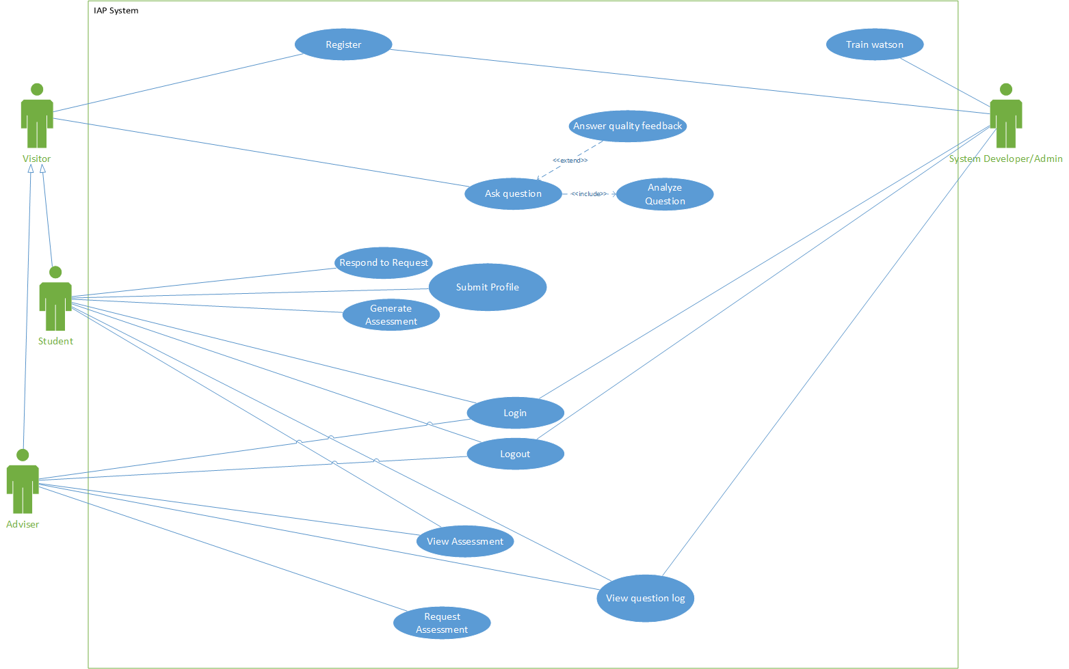This is the Use Case Diagram of our system (Intelligent Academic Planner (IAP) System). Student and Advisor share the options that Visitor has (represented by the inheritance arrows). Each blue bubble represents a functionality that is present in the system, and will be gone into detail in each use case. The functionality of Answer quality feedback is sometimes used in the Ask question functionality, and Analyze question is always used. This is represented by the “extend” arrows for situational functionality, and “include” arrows for full-time functionality done by the system.

#### User Scenarios

For a detailed description of how each Use Case performs its tasks, see Appendix U Tables 4.1 - 4.15

A **visitor** has two major use cases: Register and Ask Question. As we aim to make this system usable by anyone, users are not required to log in to ask a question. Thus, we require that the ask question functionality be available to Visitors, who are users that have yet to register.

A **student** has the ability to login, logout, respond to a request, submit a profile, and generate an assessment, as well as the same use cases a visitor has access to (ask question and register). This enables a registered student to access personality assessments and have questions catered to their personality. In addition, they can create their own personal profile.

An **advisor** has the ability to login, logout, view an assessment, view question log, and request an assessment. In addition, they have access to the same use cases as visitors (ask question and register). This allows an advisor to advise students based on questions they’ve asked and assessments they’ve received.

A **developer** has special access to tools for training Watson, displayed as the “Train Watson” use case. In addition, they have the ability to view a log of asked questions just like the adviser.

#### List of User Functional Requirements

For a detailed description of each requirement, see Appendix R Tables 4.16 - 4.42

* A user can log in
  + log-in should occur within 5 seconds
* A user can logout
  + log out should occur within 5 seconds
* A user can ask the system questions
  + System should conduct a textual analysis
  + System should gather data unique to the user
* The system should respond with multiple answers to a question
  + System should show a minimum of 1 related answer
* A user can create a profile page
  + System should allow 100-600 words of academic and professional interests
  + System should allow 100 words of self-description
  + System should create a personality assessment based on profile information
  + System should summarize profile and personality data to be used by advisors on request
* A user can register
  + Register should occur within 5 second
* A user can view a log of asked questions
  + The system should allow users to send a list of asked questions to advisors
* A user can provide information to improve the accuracy of the system
  + A user can provide answer quality feedback
* A user's session should be managed
  + A user should log out after 1 hour of inactivity
* A user's profile should be secure
  + The system should only display information the user knows is being displayed
* A user should receive a quick response to a question
  + System should provide an answer within 5 seconds of asking the question.

Note: If you are not interested in details about the individual requirements, skip to the next section. The following contains in-depth information regarding each requirement for clarity.

**Table 4.16: Log In Requirement:** This user requirement requests that we include functionality in the system for users to log in. High priority was given to this requirement since making individual sessions is required to begin work on the profile.

**Table 4.17: Log Out Requirement:** This user requirement requests that we include functionality in the system for users to log out. High priority was given to this requirement since a user should be able to log out if they can login, and log in has High priority.

**Table 4.18: Ask Question Requirement:** This user requirement requests that we include functionality in the system for users to ask the system questions. Highest priority was given to this requirement since our first priority is to allow Watson to answer questions both accurately and uniquely. In addition, since any user can ask a question, logging in and registering is not a requirement to begin work on this.

**Table 4.19: Multiple Answer Requirement:** This user requirement requests that we include functionality in the system for users to receive multiple responses to a question. Low priority was given to this requirement since it requires we first implement asking a question, which was given highest priority.

**Table 4.20: Create Profile Requirement:** This user requirement requests that we include functionality in the system for users to create a profile. Medium priority was given to this requirement since it requires we first implement registering, logging in, and logging out (all High priority) before we can set up user-specific profiles.

**Table 4.21: Register Requirement:** This user requirement requests that we include functionality in the system for users to register. High priority was given to this requirement since making individual sessions is required to begin work on the profile.

**Table 4.22: View Question Log Requirement:** This user requirement requests that we include functionality in the system for users to view a log of asked questions. Medium priority was given to this requirement because it can be easily implemented after completing the ask a question requirement, and because it will assist with increasing the accuracy of Watson.

**Table 4.23: System Feedback Requirement:** This user requirement requests that we include functionality in the system for users to improve the accuracy of the system by providing feedback. Medium priority was given to this requirement because it can be easily implemented after completing the ask a question requirement, and because it will assist with increasing the accuracy of Watson.

### Non-Functional Requirements

#### Product: Performance Requirements

**Table 4.24: Quick Answer Requirement:** This user requirement requests that when we create the functionality for asking a question, the system should respond quickly. Low priority was given to this requirement because we are focusing first on implementing features and then focusing on quality and performance of the features.

#### Product: Dependability/Reliability/Security

**Table 4.25: Secure Profile Requirement:** This user requirement requests that when we create the functionality for creating a profile, the system should ensure that the profile is secure. High priority was given to this requirement because it should be done while creating the functionality of the profile and we were encouraged to keep security in mind.

#### Organizational: Development Requirements

**Table 4.26: Manage Session Requirement:** This user requirement requests that when we create the functionality for registering, logging in, and logging out, the system should ensure that the session is managed. High priority was given to this requirement because it should be done while creating the functionality of logging in, logging out, and registering.

## System Requirements

### Functional Requirements

#### List of System Functional Requirements

**Table 4.27: Log In within 5 Seconds Requirement:** This system requirement requests that when we create the functionality for logging in, the system should log the user in within 5 seconds. Low priority was given to this requirement because we are focusing first on implementing features and then focusing on quality and performance of the features.

**Table 4.28: Log Out within 5 Seconds Requirement:** This system requirement requests that when we create the functionality for logging out, the system should log the user out within 5 seconds. Low priority was given to this requirement because we are focusing first on implementing features and then focusing on quality and performance of the features.

**Table 4.29: Textual Analysis Requirement:** This system requirement requests that when we create the functionality for asking a question, the system should conduct a textual analysis. High priority was given to this requirement because this is one of the key requirements we are focusing on.

**Table 4.32: Unique Data Requirement:** This system requirement requests that when we create the functionality for asking a question, the system should be able to gather data unique to each user. Medium priority was given to this requirement because it requires register, logging in, and logging out to be complete.

**Table 4.34: At Least One Answer Requirement:** This system requirement requests that when we create the functionality for responding with a question, the system should ask at least one question in response. Low priority was given to this requirement because creating the functionality for responding with a question is also Low priority.

**Table 4.35: Academic Profile Requirement:** This system requirement requests that when we create the functionality for creating a profile, the system should allow the user to enter between 100 and 600 words of academic and professional interests. Highest priority was given to this requirement because this is what will be to determine questions and answers related to the user.

**Table 4.36: Self-Description Requirement:** This system requirement requests that when we create the functionality for creating a profile, the system should allow the user to enter 100 words of self-description. Medium priority was given to this requirement because this will be used to determine question and answers, but will be taken into account after professional and academic interests.

**Table 4.37: View Personality Assessment Requirement:**This system requirement requests that when we create the functionality for creating a profile, the system should allow the user to view personality assessments. High priority was given to this requirement because this is one of the main resources advisors will use.

**Table 4.38: Generate Personality Assessment Requirement:** This system requirement requests that when we create the functionality for creating a profile, the system should allow the user to generate personality assessments. Medium priority was given to this requirement because it requires the 100 words of self-description to be complete.

**Table 4.39: Summarize Data Requirement:** This system requirement requests that when we create the functionality for creating a profile, the system should summarize data for advisors. Medium priority was given to this requirement because it requires the profile to be fully complete before a summarization can be created.

**Table 4.40: Register Within 5 Seconds Requirement:** This system requirement requests that when we create the functionality for registering, the system should register the user within 5 seconds. Medium priority was given to this requirement because we are focusing first on implementing features and then focusing on quality and performance of the features but this will be one of the first features users encounter, so it has a slightly higher priority than login and logout performance requirements.

**Table 4.41: Question Log to Advisor Requirement:** This system requirement requests that when we allow students to send questions they have asked to their advisor. Medium priority was given to this requirement because the functionality of the question log is also medium priority.

**Table 4.42: Ask For Feedback Requirement:** This system requirement requests that when we create the functionality for providing feedback, the system should ask for the feedback after asking a question. Medium priority was given to this requirement because the functionality of providing feedback is also medium priority.

#### System Behavior

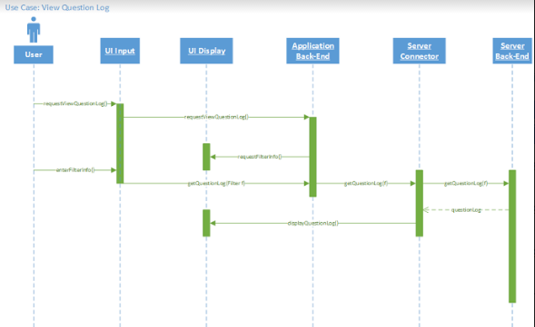

**View Question Log Sequence Diagram:** After requesting to view the question log, the system will ask for filter info and then display the question log for viewing to the user after receiving the questions from the server’s back-end.

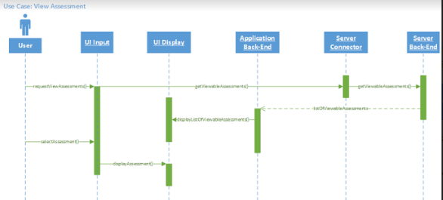

**View Assessment Sequence Diagram:** After requesting to view an assessment, the system will display a list of viewable assessments. Once the user selects which assessment they wish to view, the system will display the assessment information on the screen.

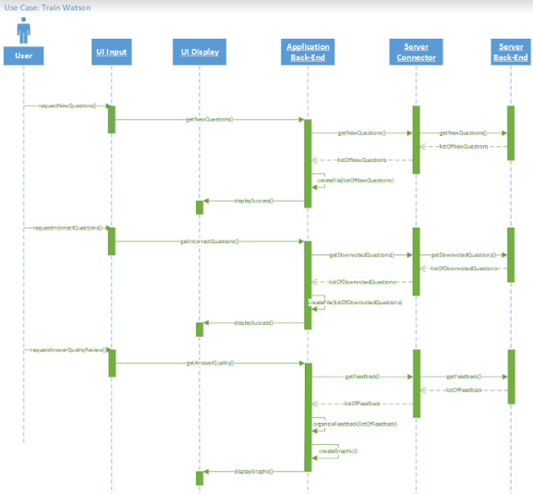

**Train Watson Sequence Diagram:** After the user either requests new questions, incorrect questions, or quality feedback, the system responds by creating a file with a list of the questions matching the filter or a graphic (such as a bar graph) of the quality feedback.

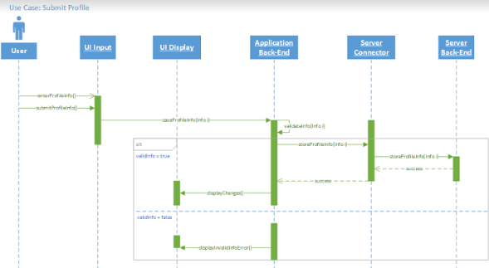

**Submit Profile Sequence Diagram:**  After a user inputs their profile information and requests to save, the system validates the information to ensure that there is no invalid or dangerous input. If it passes validation, the information is saved and a message stating that it was saved is displayed. Otherwise, a message displaying that there was a problem is displayed.

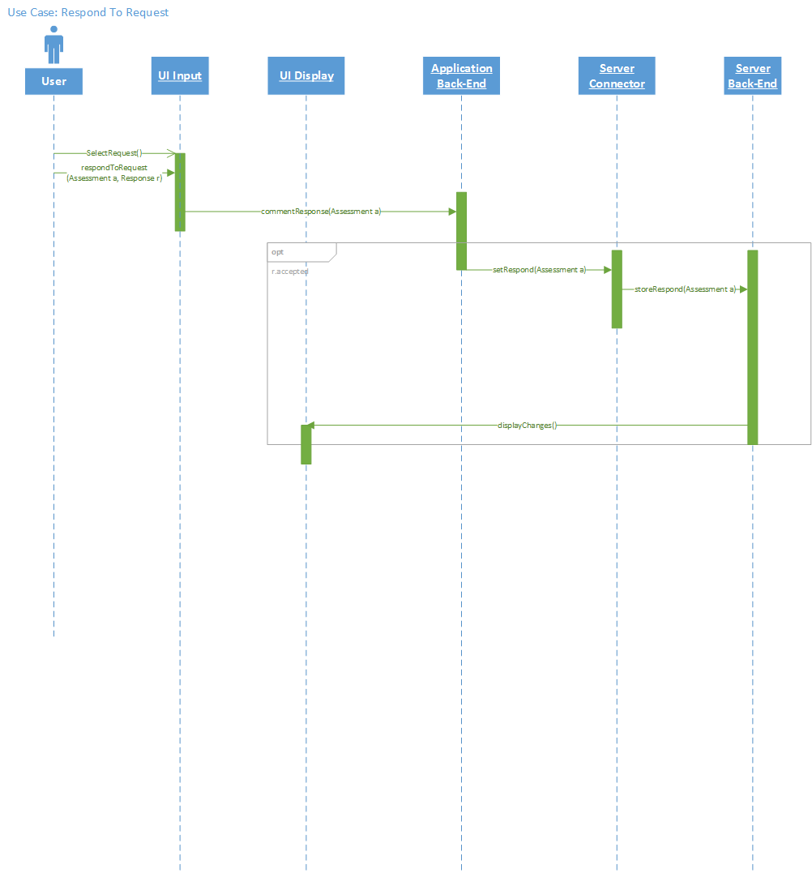

**Respond to Request Sequence Diagram:**  After the user selects the request they with to respond to and submits their response, the system sends a message back to the requester, sets the visibility of the selected requested assessment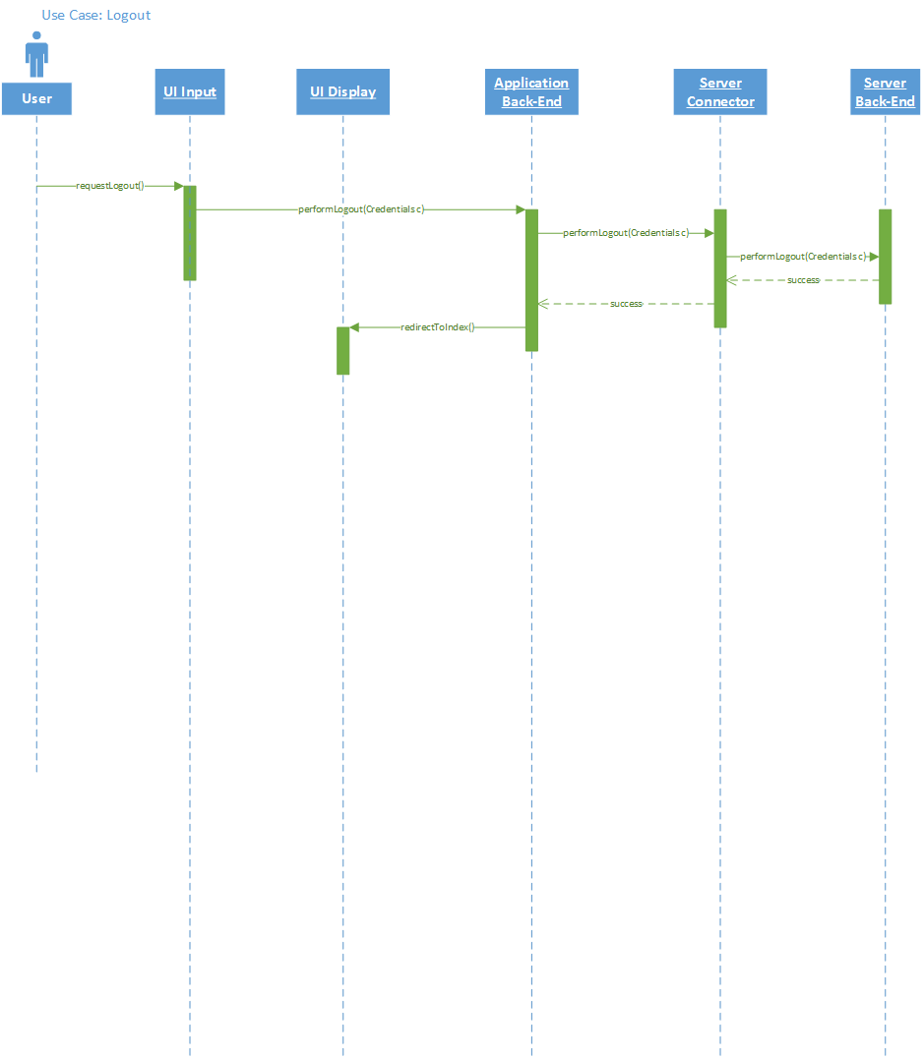

**Logout Sequence Diagram:**  After a user requests to logout, the system logs the user out of the server and redirect user to index page.

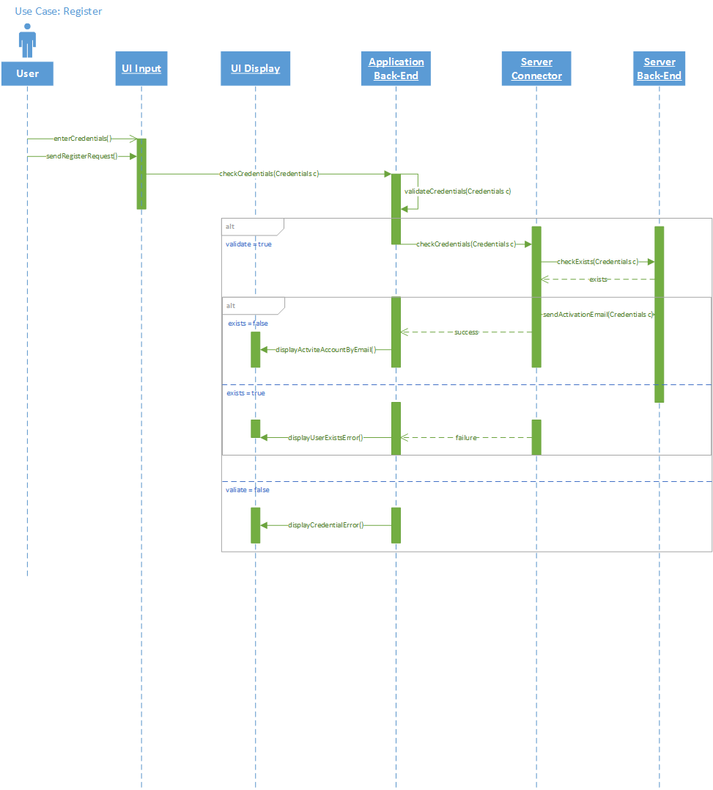

**Register Sequence Diagram:**  After the user enters credentials and requests to register, the system checks the credentials to see if they meet the requirements (email format, correct number of characters, etc). If valid, the system checks if a user with the same email already exists. If a user does not exist, the system adds a new user (Inactive) to the database and displays success with message guide user active account by email that used in registration. If a user with the same email already exists or the credentials do not meet requirements, an error message is displayed.

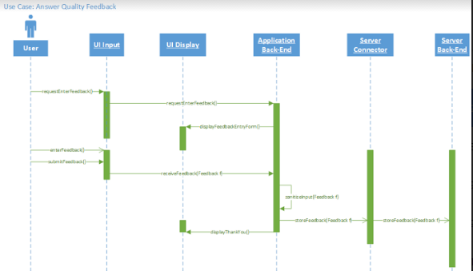

**Answer Quality Feedback Sequence Diagram:**  After a user requests to enter feedback, an entry form is displayed for the user to input the feedback. Once submitted, the system checks to make sure the input is not dangerous, then stores it in the database, and finally displays a thank you message to the user.

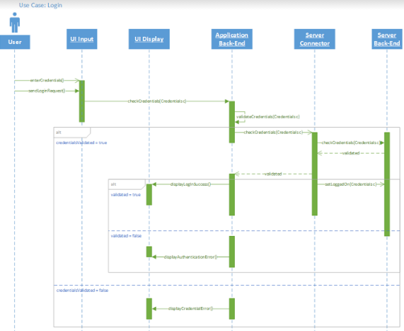

**Login Sequence Diagram:**  After the user enters their credentials and sends a login request, the system checks the credentials to see if they meet requirements first, and then checks to see if they are valid. If the credentials meet requirements and are valid, the user is logged on and a success message is displayed. Otherwise, an error message is displayed.

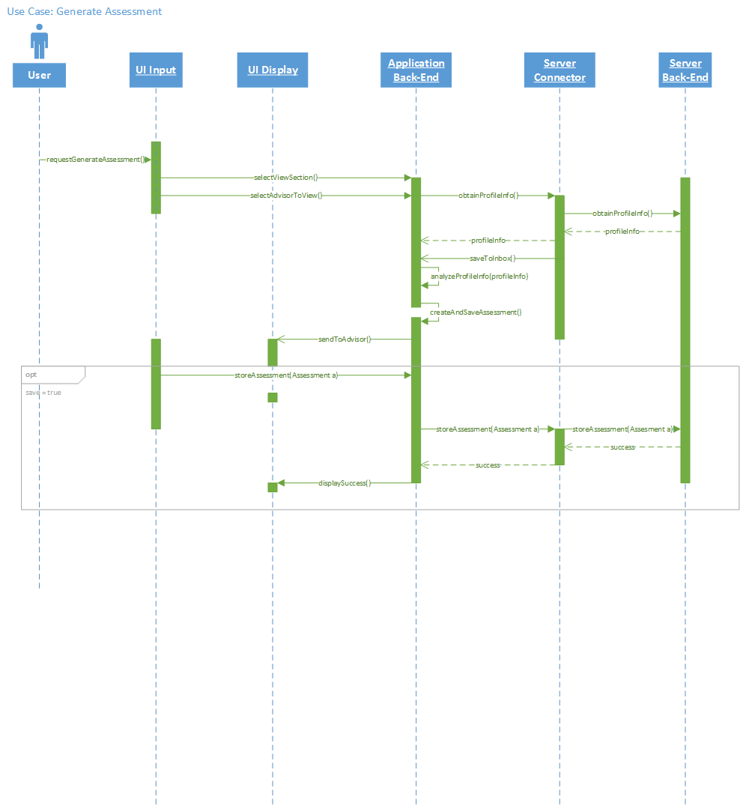

**Generate Assessment Sequence Diagram:**  When the user requests to generate an assessment, the system ask what section should be included in the assessment, then obtains corresponding profile information and analyzes it. Once analyzed, an assessment is created and send to advisor. The system then automatically save the assessment to the inbox.

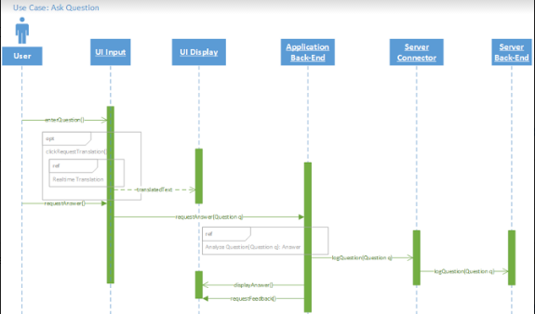

**Ask Question Sequence Diagram:**  When the user enters a question, they can request translation before requesting their answer. Once an answer is requested, the system calls to Analyze Questions and performs the functionality and returns the answer. The question is then logged and the answer is displayed. After the answer is displayed, the system asks for feedback.

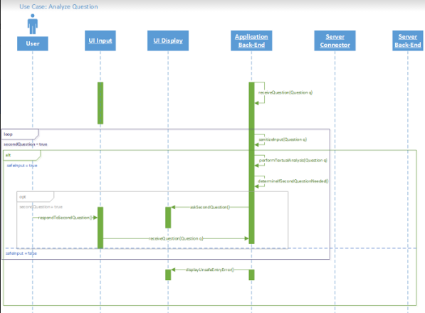

**Analyze Question Sequence Diagram:**  The system receives a question from the Ask Question functionality. First, the system checks to see if the question is dangerous. If it is not dangerous, a textual analysis is performed. After the textual analysis, the system determines if it needs to ask a second question. If a second question is needed, it displays it to the user and then awaits input. The process above is repeated until another question no longer needs to be asked.

#### 

#### 

#### Data Requirements

* **UC001** - Input: User whose assessment is being requested.
* **UC004** - Input: User email address and real name for registration and login.
* **UC004** - Input: User password for registration and login.
* **UC006** - Input: Filter information for useful question log (eg. major, minor, courses).
* **UC007** - Output: List of newly generated questions exported to a text file.
* **UC007** - Output: List of unanswered frequently asked questions.
* **UC010** - Input: User feedback pertaining to the relevance of the responses to their questions.
* **UC011** - Input: User questions.
* **UC011** - Output: Responses to user questions.
* **UC013** - Input: User profile.
* **UC015** - Output: User assessment based on their profile and search history.
* **UC019** - Input: The advisor who is requesting the student’s assessment.

### Non-Functional Requirements

#### Product: Performance Requirements

**Table 4.43: Answer Question Within 5 Seconds Requirement:** This system requirement requests that when we are ensuring that an answer is providing quickly, we should test that it answers within 5 seconds. Low priority was given to this requirement because we are focusing first on implementing features and then focusing on quality and performance of the features.

#### Product: Dependability/Reliability/Security

**Table 4.44: Secure Profile Requirement:** This system requirement requests that when we are ensuring that a profile is secure, we should test that it only displays information that the user has set to be public. High priority was given to this requirement because it should be done while creating the functionality of the profile and we were encouraged to keep security in mind.

#### Organizational: Development Requirements

**Table 4.45: Manage Session Requirement:**This system requirement requests that when we are ensuring that a user’s session is managed, we should test that it logs the user out after 1 hour of inactivity. Low priority was given to this requirement because while it is connected to logging in, logging out, and registering, it is not critical to other functionality of the system.

## Requirements Trace Table

See Table 4.46: Summary of Requirements in Appendix R.

# Exploratory Studies

## Relevant Techniques

Our team distributed a survey, containing both qualitative and quantitative questions, to 150 students in an introductory Computer Science course. Our intention was to receive feedback relevant to the thoughts and decision-making processes of a student who has recently completed high school and is considering a degree and career in Computer Science, Software Engineering, or Computer Engineering. We also accepted the input of upper level classmen with the belief that their input could provide important feedback about the information they have gathered and decisions they would have made, in hindsight.

* Qualitative Data: Open-ended questions “can lead to the discovery of new initiatives or problems that should be addressed.” [8]
  + If your major/minor has changed, what was it and why did it change?
  + What are the best and worst features of your field of study?
  + Why did you choose to study at Behrend?
  + What questions/concerns did you have when deciding on your major and school?
* Quantitative Data: Closed-ended questions “allows researchers to categorize respondents into groups based on the options they have selected.” [17]
  + What year are you? (Freshman, Upper)
  + What is your major and minor?

While many of our questions were based on the responses of the surveys, some students did not return their survey, some students did not ask five questions, and many students repeated questions asked by their peers.

$$(150 surveys ×\frac{5 questions}{1 survey}-duplicate questions) ≤750 unique questions$$

This is a generous calculation of how many questions we were able to create based on the surveys.

Many additional questions were created through research conducted on the internet. Watson was initially trained with 1000 question-answer pairs to ensure depth and accuracy of system knowledge.

An additional 4000 questions were later added to the system; the questions were based on the original 1000. For example, if the statement “Tell me about Erie.” was already in the system, then the questions “What is Erie like?” and “Can you tell me more about Erie?” would have been added. Our intention was to ensure that the system had many variations of question. We believed that this would increase the Watson’s accuracy and understanding. To our surprise, with the additional questions and training, Watson began to answer with less accuracy. Although much time was lost in retraining, knowledge of Watson’s learning process was gained. References 18-52 were used to generate both questions and answers for our domain.

* The following are examples of question-answer pairs:
  + Q: Does Penn State Behrend assist students in finding internships and employment opportunities?  
      
    A: Penn State Behrend holds a career fair once a semester where a hundred or so different companies come and you can speak with them. In addition, once you post your resume to Nittany Lion Career Network, the career center will start sending your resume out to potential employers, who will then contact you without you having contacted them yourself. Kinda nifty, in my opinion.
  + Q: Do Computer Engineers get hired by companies like Google, Microsoft, Amazon, and Facebook?  
      
    A: Yes. All four of those companies require computer engineers, but they have much more rigorous interviews than most companies. You can get hired, you just need to be very well prepared for the interviews.

Our system will use keyword-concept extraction to update the frequency of each question being asked. This will continue recording into the database, for future analytical use. Our system will use machine learning algorithms to format, structure, and extract data in order to update question-answer tracking and add new useful information, if is not currently in our knowledgebase. Similarly, by crawling data from user feedback, we can track users’ questions to check whether they are related to our knowledge domain, and either update the related information or add new data from the user input.

* Data Crawling
  + Question Log: update frequency of each asked question, extract new keyword and concepts to add to our knowledge domain.
  + Suggested Feedback: answers for unclear questions - updating better answer to our knowledge domain.
  + Analysis Data: data gleaned from user’s input.

Our system should be able to interpret questions delivered in Natural Language. We will use tags and information extraction to ensure that the user’s question is being addressed and understood properly. For example, our system will understand that the word “what” is indicative of a question. Our system should also be able to comprehend “questions” asked in a non-standard manner. For example, an input of “Penn State retention rate” should be interpreted as a question rather than a statement.

* Natural Language Processing (NLP) [9]
  + Generative Models for Parsing
    - Parse Trees
      * Part-of-Speech
      * Useful Relationships
    - Context-Free Grammar
  + Log-linear Taggers
    - Information Extraction
    - Named Entity Recognition
    - Relationships between Entities
    - Named Entity Extraction as Tagging

Our documents must be curated to ensure that the information our system is providing is reliable and accurate. This can done by feeding a variety of informational documents to our system and allowing the system to verify the information’s validity through comparison of the sources.

* Document Curating [10]
  + Exact match search
  + Wildcard search
  + Proximity search

We plan to use a basic exhaustive search and complete training with fixed training data (our knowledge base). Our system will use a natural language classifier to determine what information is useful. This can be substituted by the Conversation API from Watson.

* Machine Learning Algorithms [11]
  + Supervised Learning
    - Linear Regression
    - Decision Tree (classification)
  + Unsupervised Learning
    - Gensim (python)

Use to compare string similarity

* + - NLTK (python)

For data mining purpose

* + - MonkeyLearn (Web)

Use web service to build automated training mode

## Relevant Packages/Products

Watson services are accessed by APIs usually programmed in the CURL, Java, or NodeJS languages. Since this project is a web application, NodeJS has more native support on the server side, and faster performance in general execution and implementation. A NodeJS server will call Bluemix RESTful Watson APIs on server usage and query MongoDB natively in the format of JavaScript. The application will have NLP handling and analysis functionalities embedded. The development team could also use Hadoop for analysis, since it is especially good for managing Big Data. Since the intention is to maximize usage of Watson services, the best option for the team is to use Natural Language Understanding. MongoDB will store the data of three perspectives: user account, user question log, and analysis of all kinds of records that are needed by administration.

* NodeJS[12]
  + Server application type
  + We decided to use this because most of the Bluemix APIs are designed for Node.JS handling and Node.JS is an advanced, efficient server application.
* Watson Platform
  + Conversation[5]
    - Mainly used to classify the question input from user and determine if the question is in our domain or not.
  + Retrieve and rank[4]:
    - Core functionality of the project
    - Uses machine training and NLP(Natural language process) to study the training dataset and provide feedback on the answer with an accuracy measurement.
  + Personality analysis[16]
    - Assessment functionality to generate personality analysis for user. This will allow us to give more specific answers to a user based on their personality.
* MongoDB[14]
  + Main non-relational DB for the application, since we will handle a lot of unstructured data.
  + MongoDB has good features to store and sort.
* Natural language processing
  + Monkey learn[2]
    - A mature public accessible API provider to do NLP analysis
  + Natural[9]
    - Equivalent NodeJS library of NLTK(Natural language toolkit) in python. It mainly focuses on customized NLP classification.
  + Natural Language Understanding[3]
    - Similar to Monkey learn, but is managed by IBM. It will provide feedback on the detailed analysis of a sentence, so we can analyze parts of sentences to determine the intent of the question.
* Hadoop
  + The core of Apache Hadoop consists of a storage part, known as Hadoop Distributed File System (HDFS), and a processing part called MapReduce. Hadoop splits files into large blocks and distributes them across nodes in a cluster.

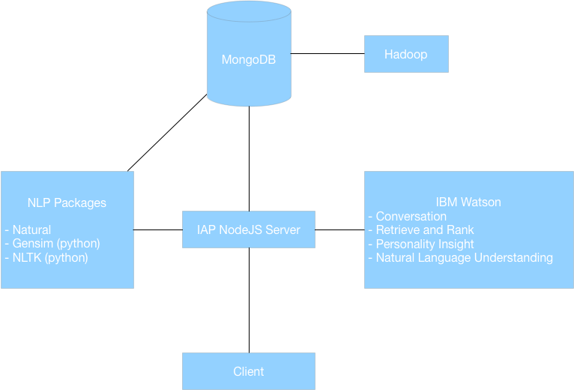

*Relevant packages/products flow diagram*

## Broader Impacts

This project can be expanded to include other majors within Behrend or branches of Penn State University. On a grand scale, this type of tool would be beneficial for high school juniors and seniors, as well as college freshman and anyone participating in the role of student advisement.

# System Design

## Architectural Design

* Layered Architecture
  + Client-Server-Database model
  + Server handles all computation and updates
  + Server query with DB
  + Feedback data to client side

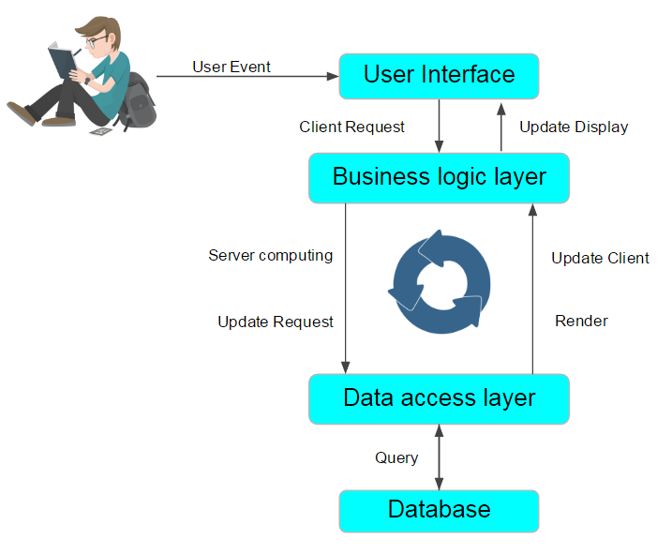

User initializes a “submit question” event on the web browser, then the server will handle the question through the logic layer. The database can then be queried and, if there are no exceptions, the data will be sent to Watson through Bluemix RESTful APIs. Finally, the response information will be returned in the reverse direction.

## Structural Design

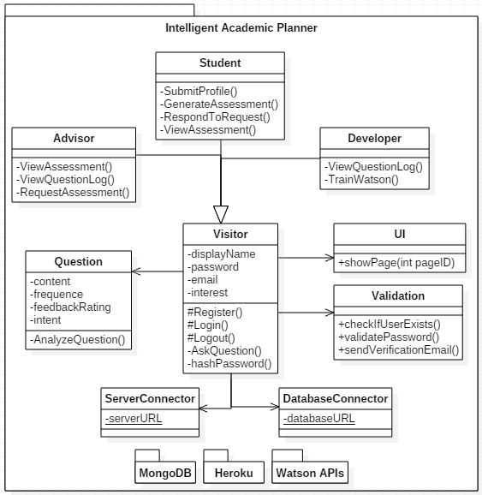

This is the class diagram of our system. We are using Heroku as our server and MongoDB as our database. All visitors have the ability to ask questions, and questions are stored on our server. The Validation class is used to check for safe and correct inputs, improving security of our system.

## 

## 

## User Interface Design

The user interface is split into several web pages: Ask Questions, Login & Register, User Profile, Inbox, and Advising (for advisor accounts). The design is responsive and can be viewed on both desktop and mobile devices. A navigation bar is present on each page to ensure easy navigation.

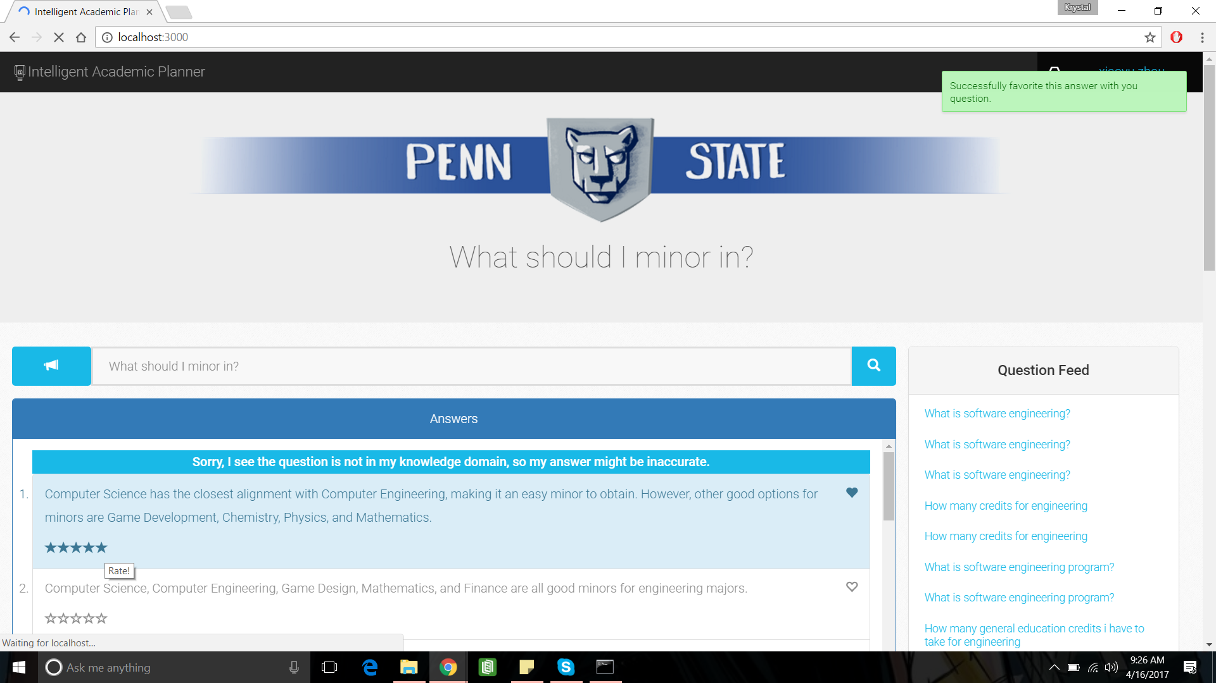

Ask Questions: This is the landing page of our site. A user can ask a question in the search bar, using voice-to-text or textual input. The answers are displayed in list form, with the ability to “Favorite” a preferred answer and give the system feedback through a 5 star rating system. A question feed column is placed along the side of the page to inform users of recently asked questions and to allow them to view their responses.

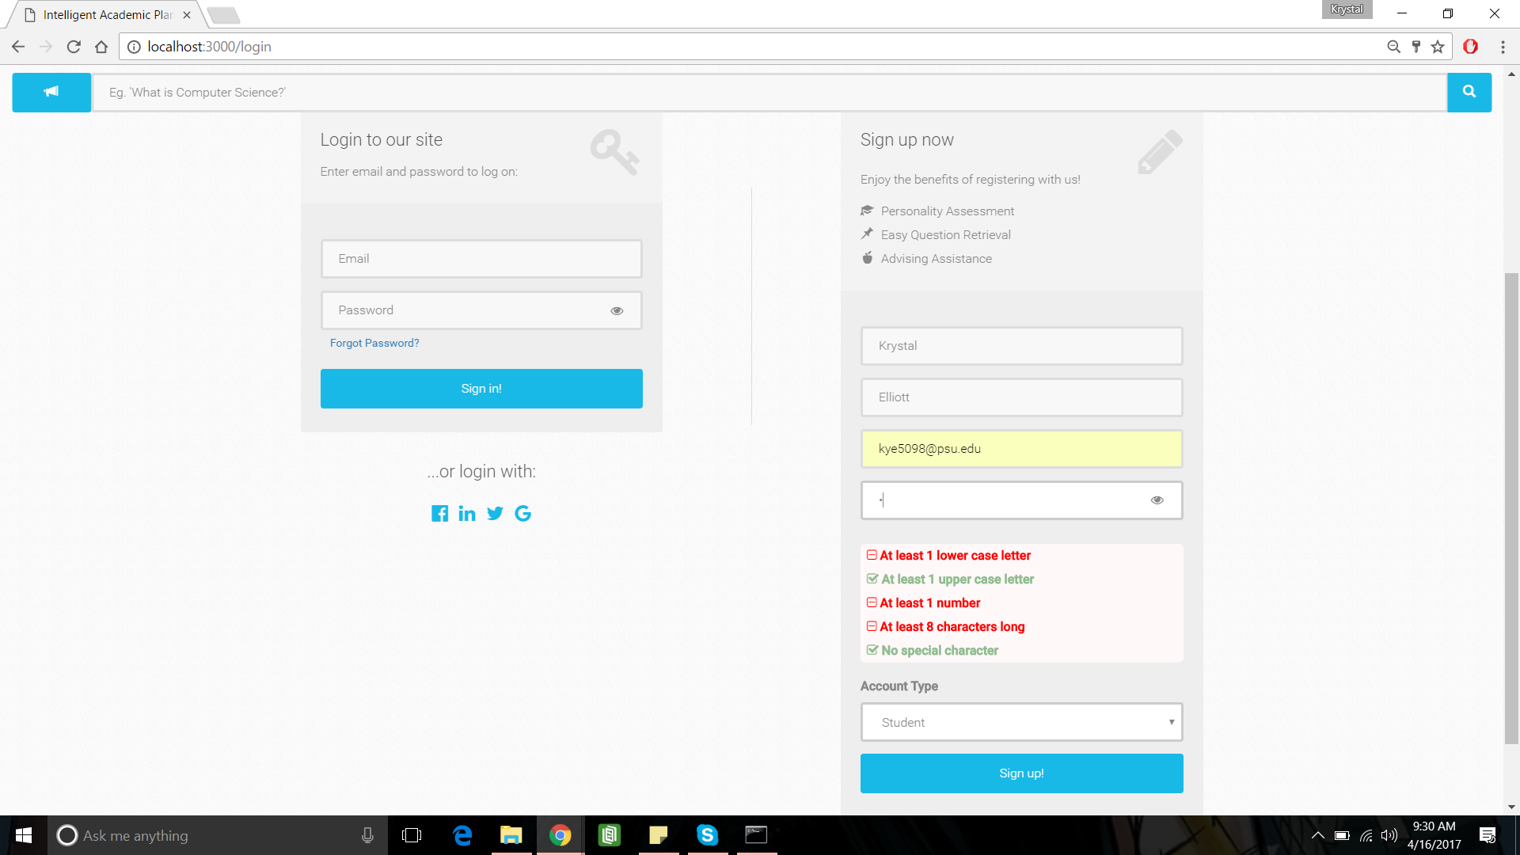

*Login & Register: A search bar is at the top of the page to allow a user to ask a question from any page. The user must register with their name, an email, and password. The user must also choose an account type of Student, Advisor, or Developer. There are password requirements as well as the ability to retrieve a forgotten password. A user can login with their Facebook, LinkedIn, or Google account. The account must be activated before it will become active.*

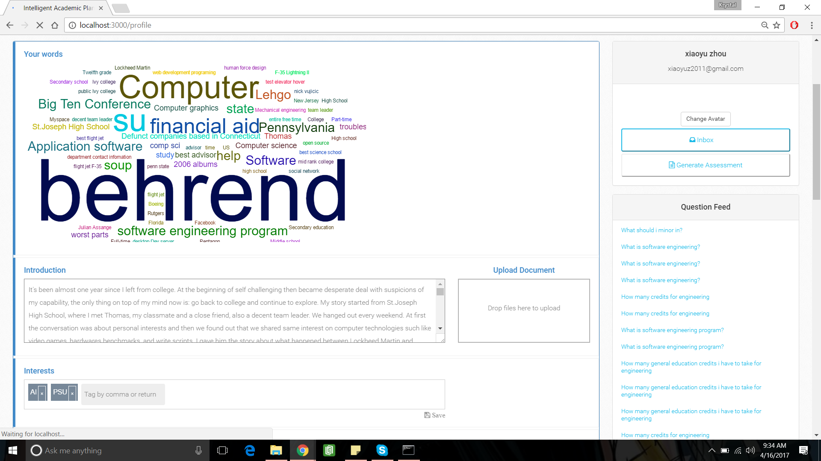

*Profile: Only available after login, display information about the user, including: a conglomeration of words describing the user’s interests, a profile picture, an introduction written by the user about the user, and interests. This page also features the Question Feed and Search Bar.*

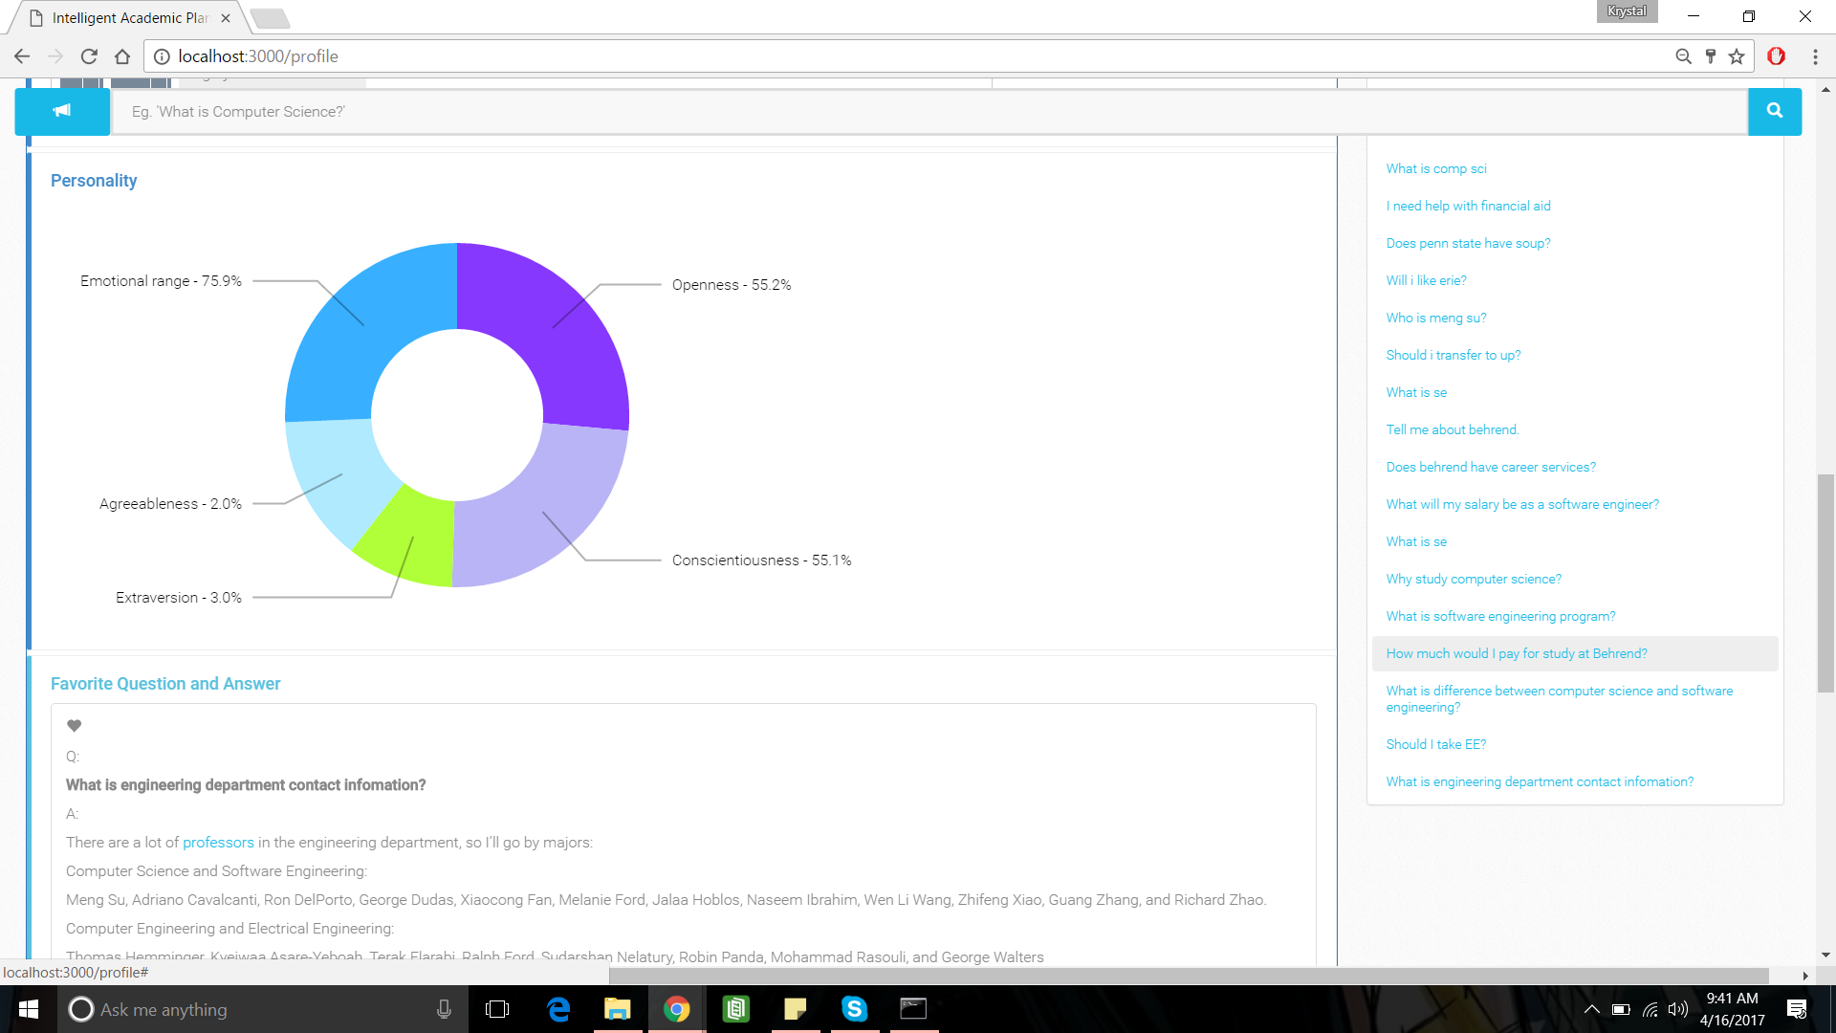

*Profile: Further down the Profile page, there is a personality assessment, displayed as a graph depicting the Big 5 Personality Traits*[53]*, as well as the user’s favorite question-answer pairs.*

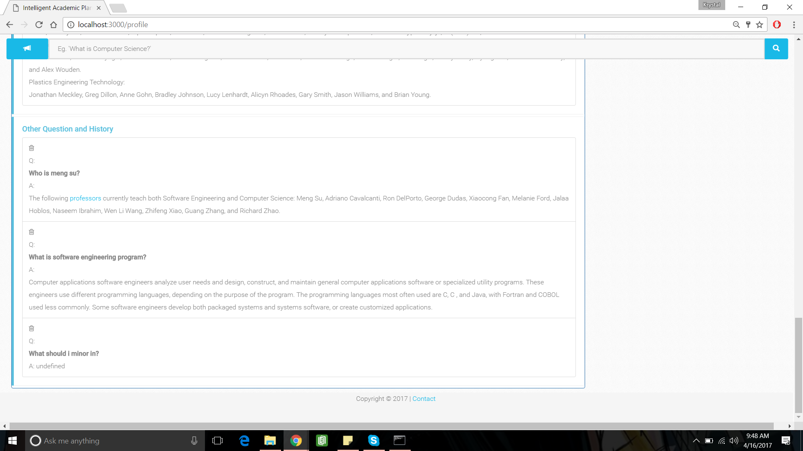

*Profile: The bottom of the profile page will display all of the user’s questions and the top answers associated with each.*

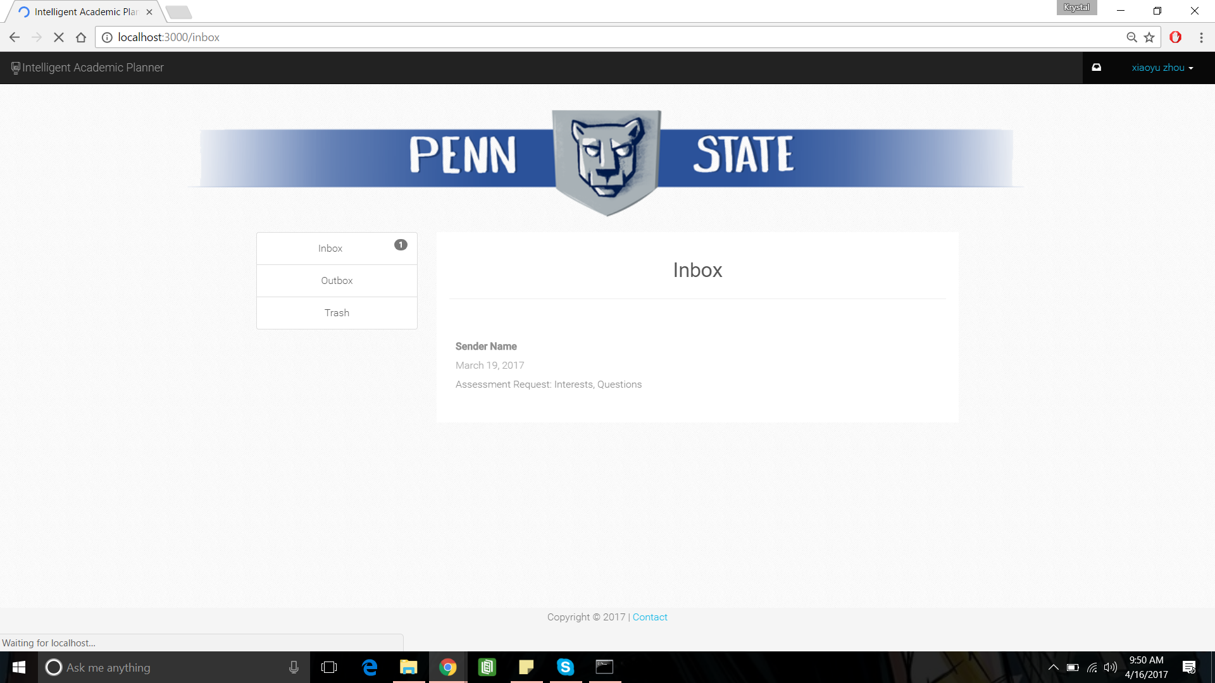

*Inbox: The Inbox will host the generated assessments.*

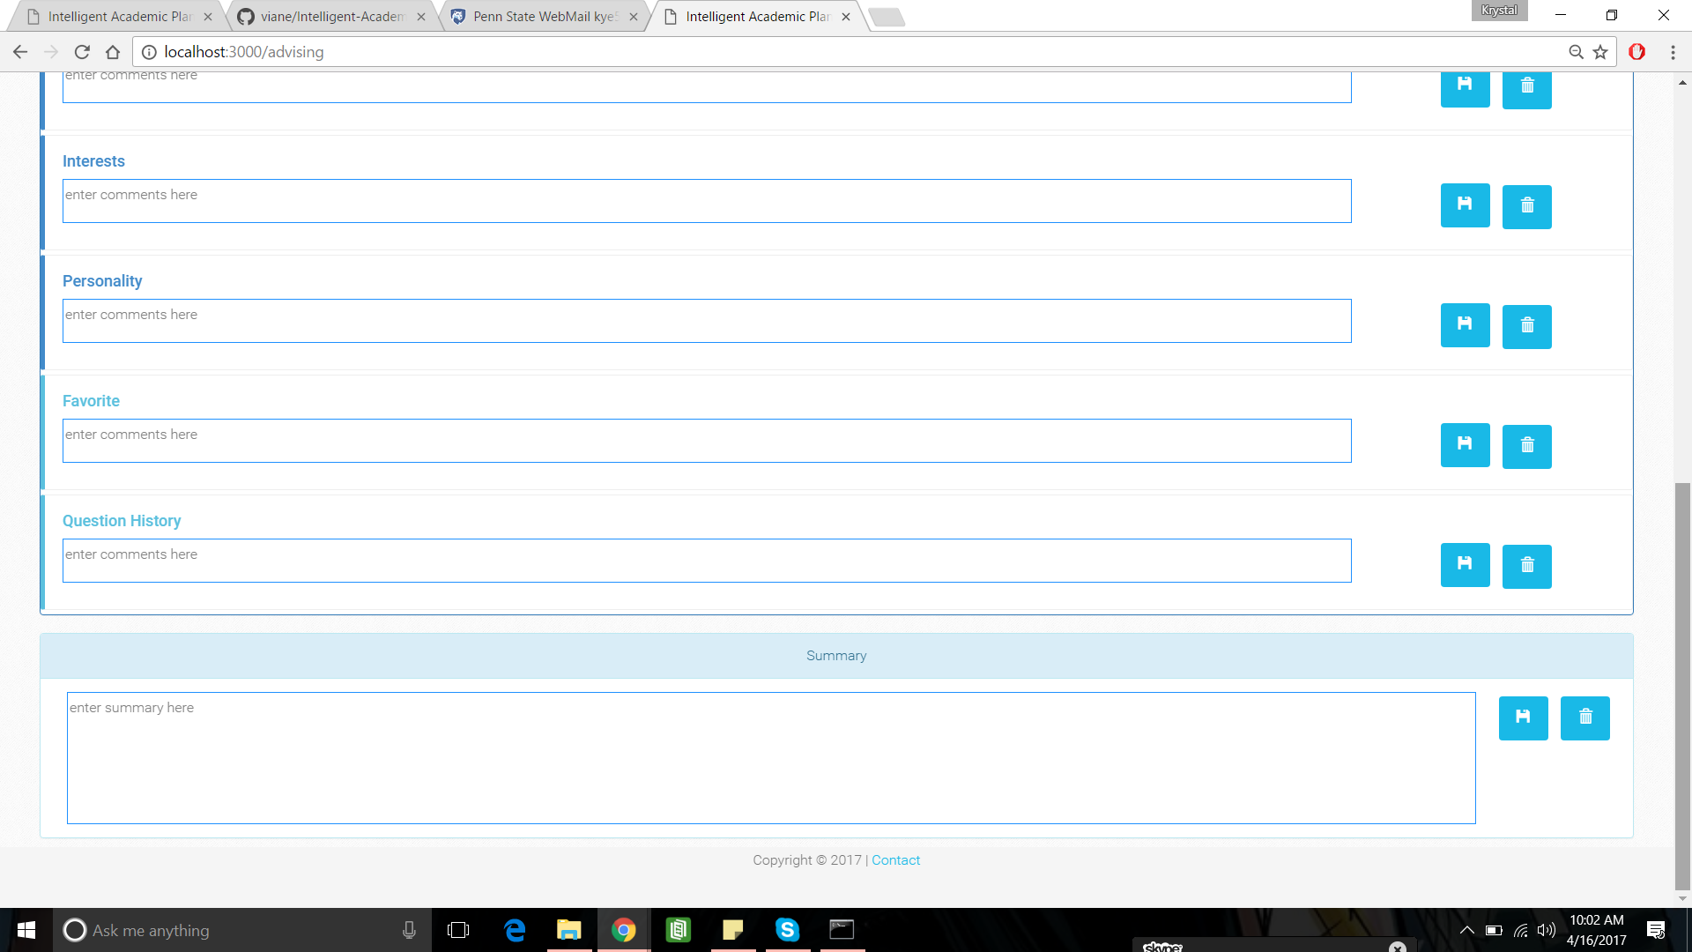

*Advising: The Advising page will consist of the same fields contained within a student profile. Each section will be populated with the information from the student who sent the assessment. There is an opportunity for the advisor to leave a comment below the section. At the bottom, there is a place for the advisor to leave a summary of what they would recommend for the student.*

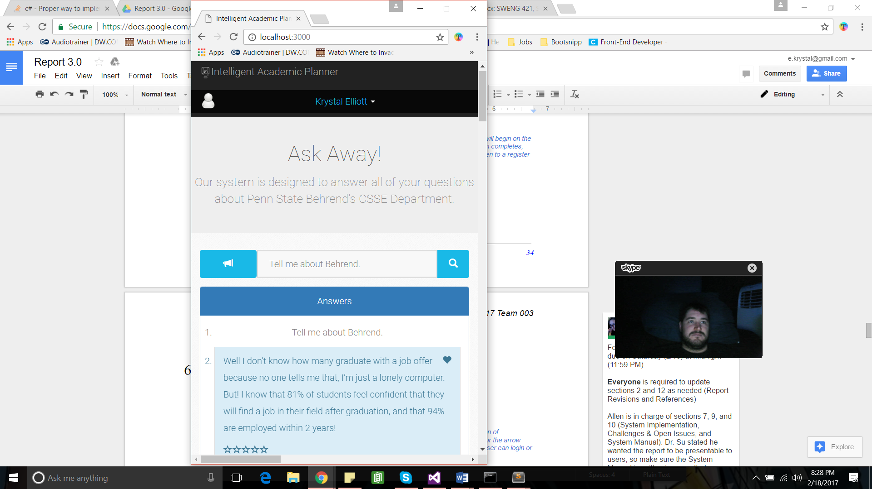

*Responsive Design: This is an example of the view of the Ask Question page on a mobile device.*

## Behavioral Design

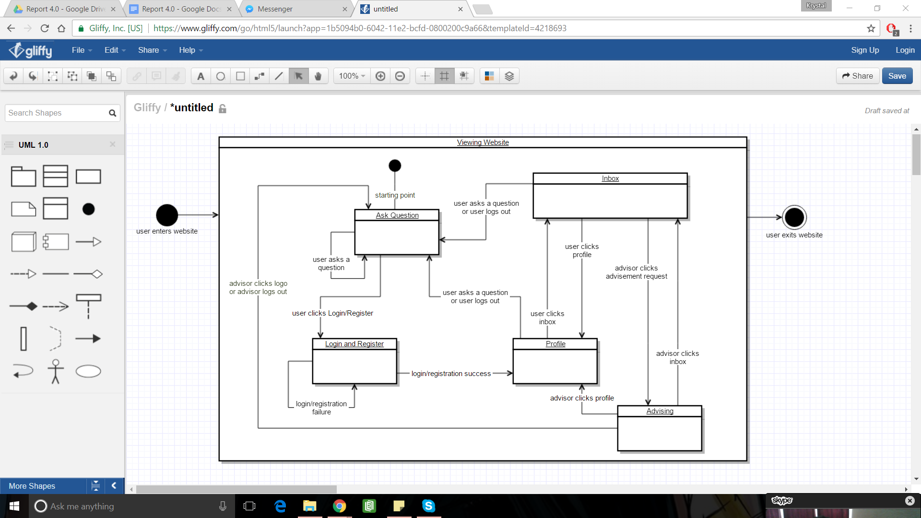

This is the state diagram for the webflow of the website where users ask the questions. Users will begin on the Ask Question page. If the user clicks the login/register button, they will be taken to the login/register page. When login or registration completes, they will be taken to their profile page. From any location in the system, if they click on the home button, they will be taken to the Ask Question page and if they click on the logout button, they will be taken to the login page. The user can navigate to the inbox via the inbox button. An advisor can navigate to the advising page via a requested assessment in their inbox.

## Design Alternatives & Decision Rationale

### UI Alternative Designs

These are alternative user interfaces.

#### Version 1.0

The view will be divided by 2 main sections, left side navigation of functionalities and right section of display/interactions. The user enters the question on the line at the bottom and either hits enter or the arrow button to submit the question. As the question is being answered, a loading icon appears. The user can login or view their profile using the buttons on the left side.



**Ask Question**: use mobile compatible view design template

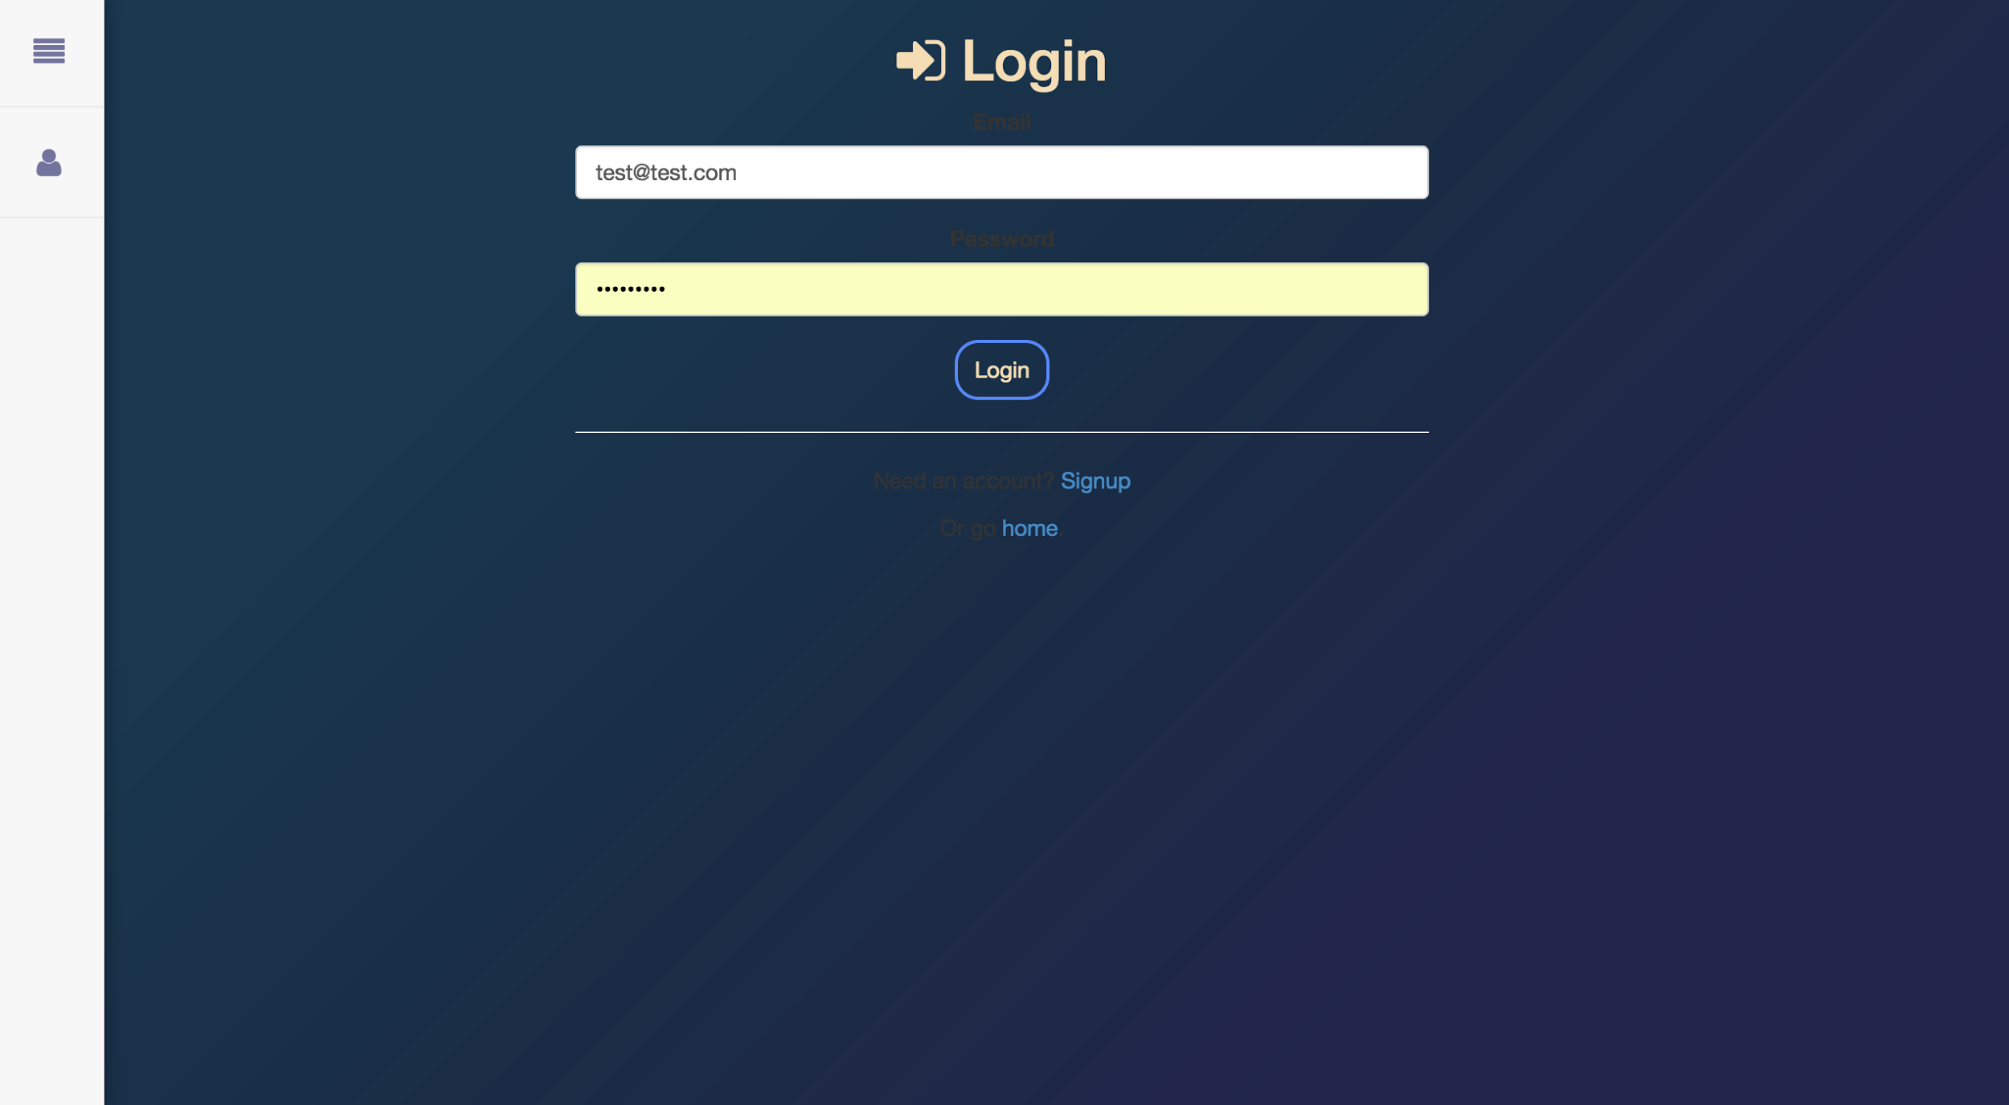

***Login****: require register email and password*

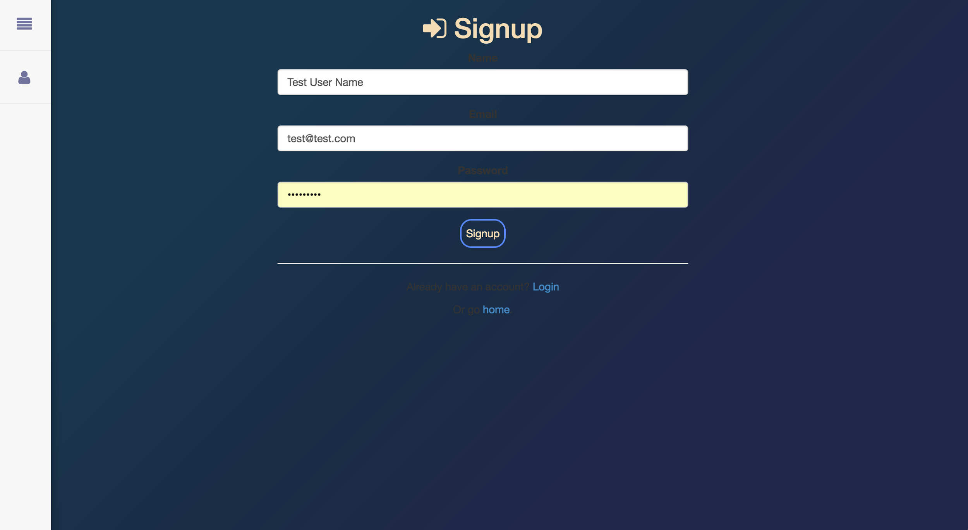

***Register Account****: require a display name, register email, and password*

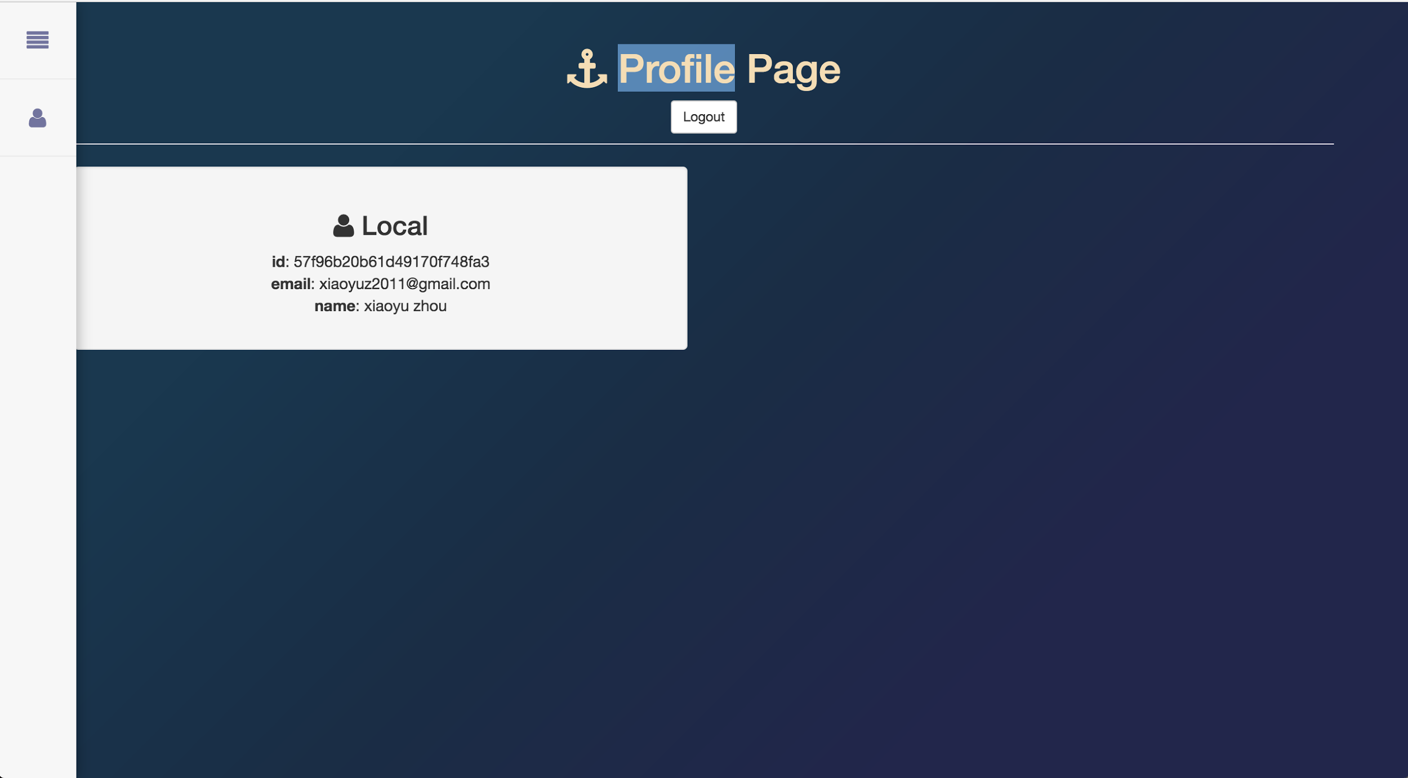

***Profile****: only available after login, display regular account information*

#### Version 2.0

The color scheme is much brighter and it includes additional screens, which have not been included in the original UI design. This design is fairly simplistic and would allow for a user to access the project via their mobile device, as well.

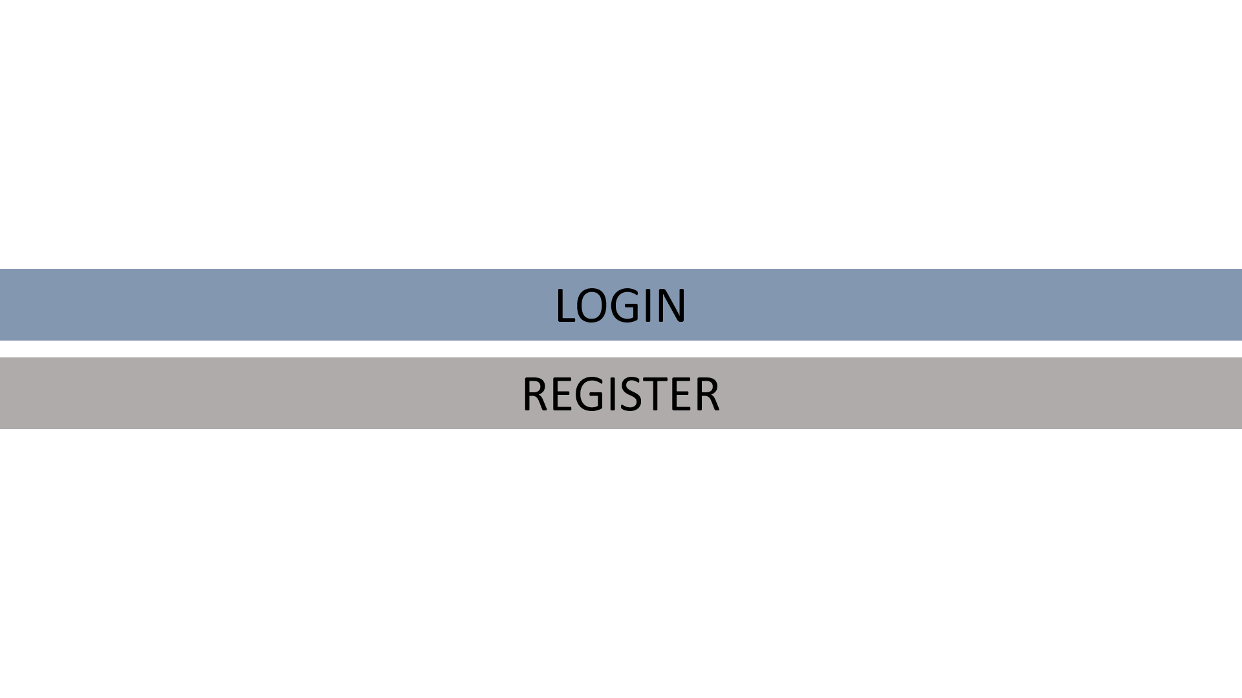

**Landing Page:** offers options of logging in and registering

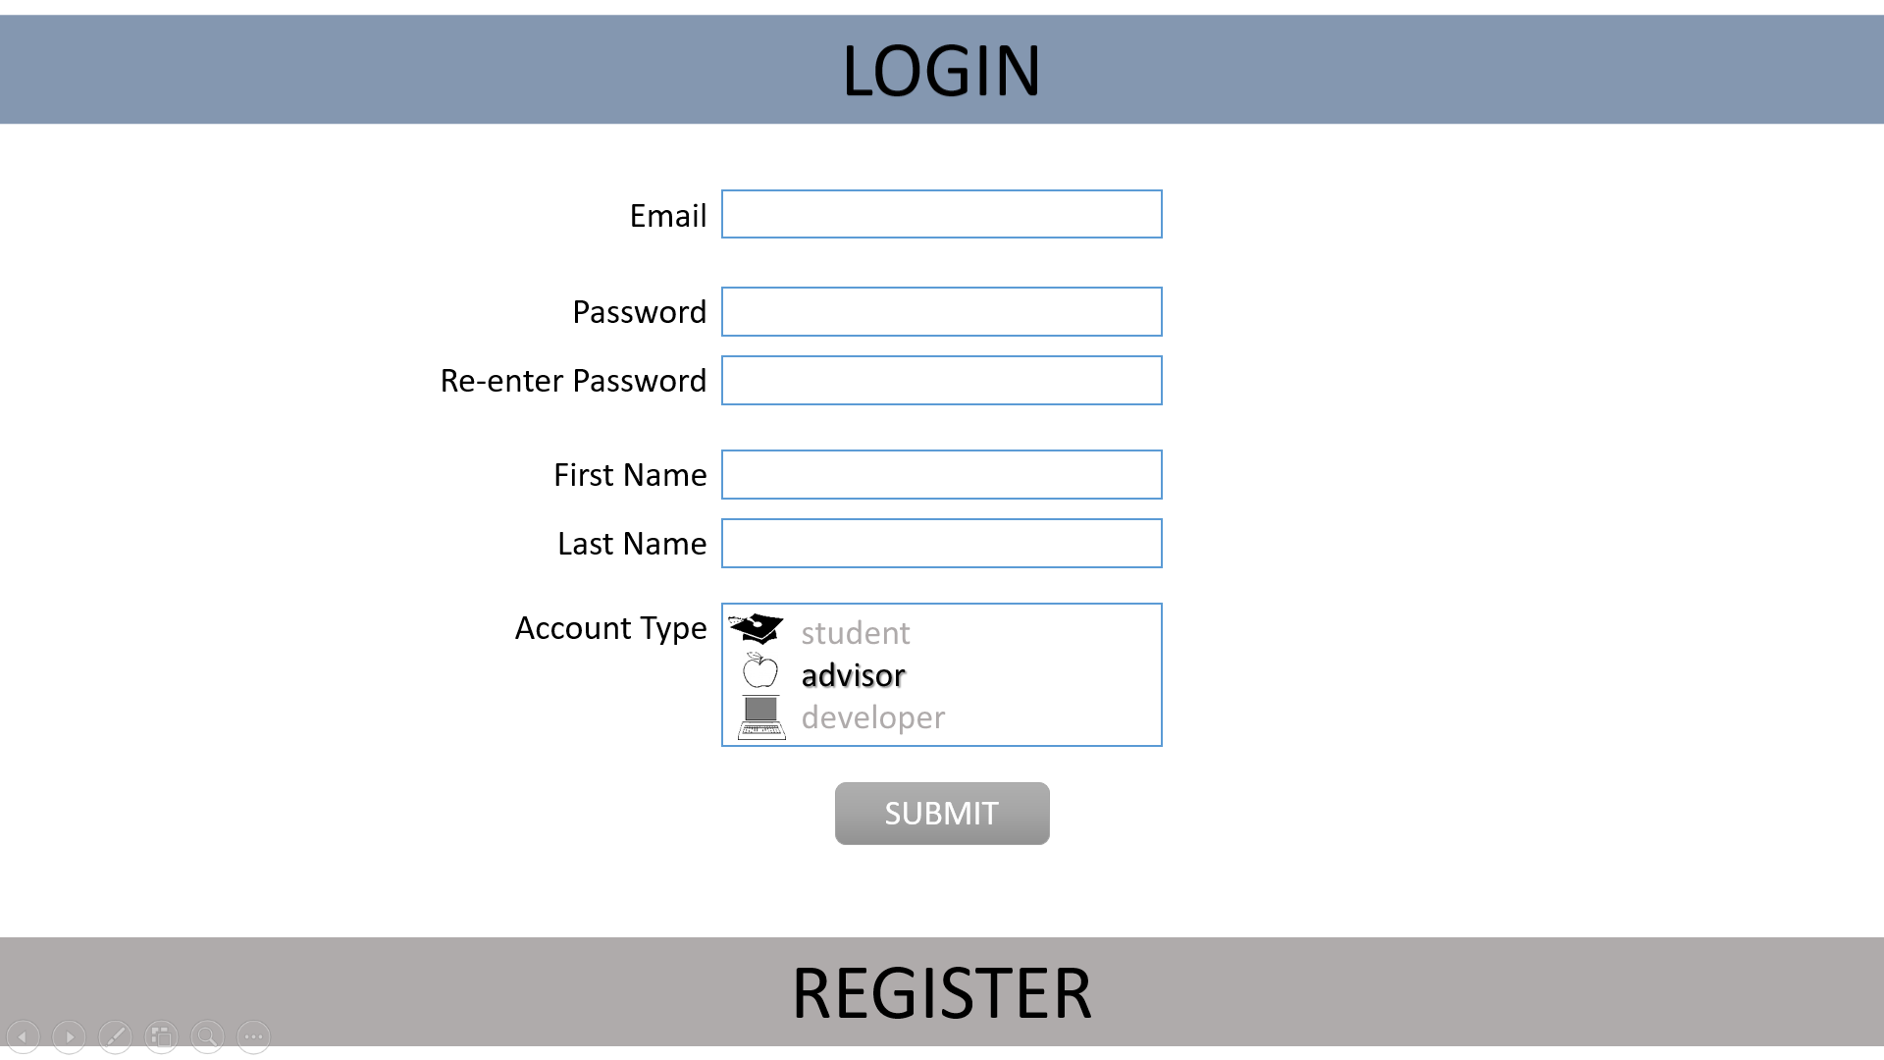***Registration:*** *collects user data to create an account*

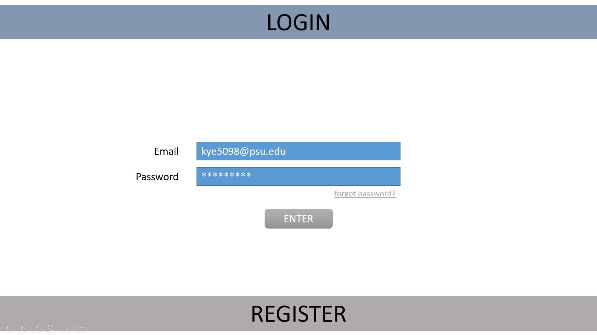

**Login:** allows user to login

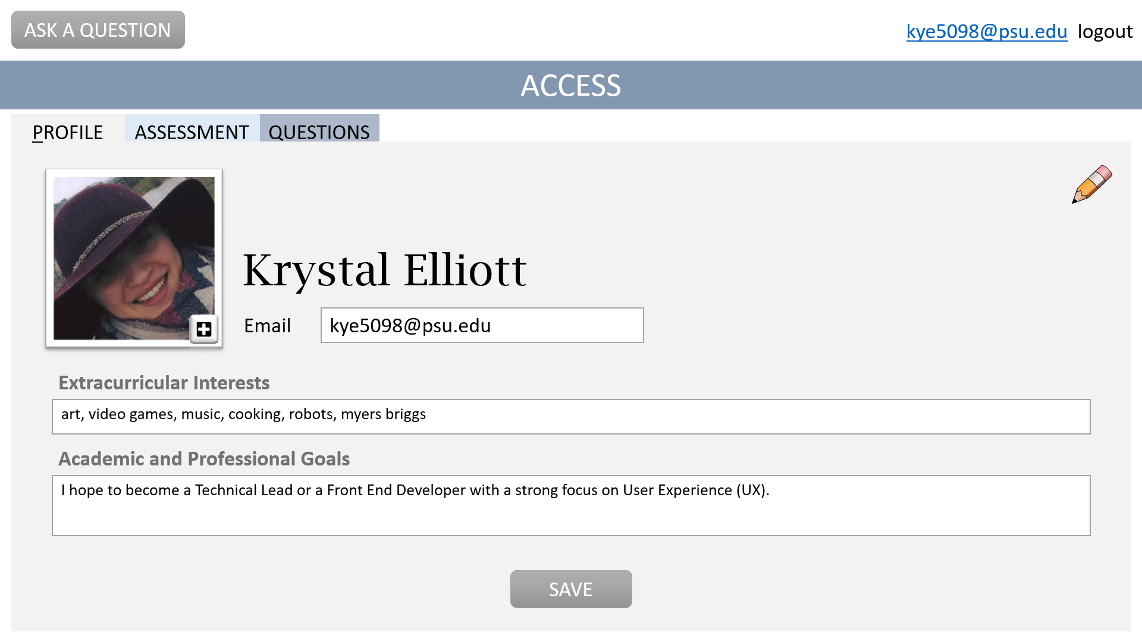***User Profile:*** *allows user to create a personal profile, complete with picture, interests, and goals*

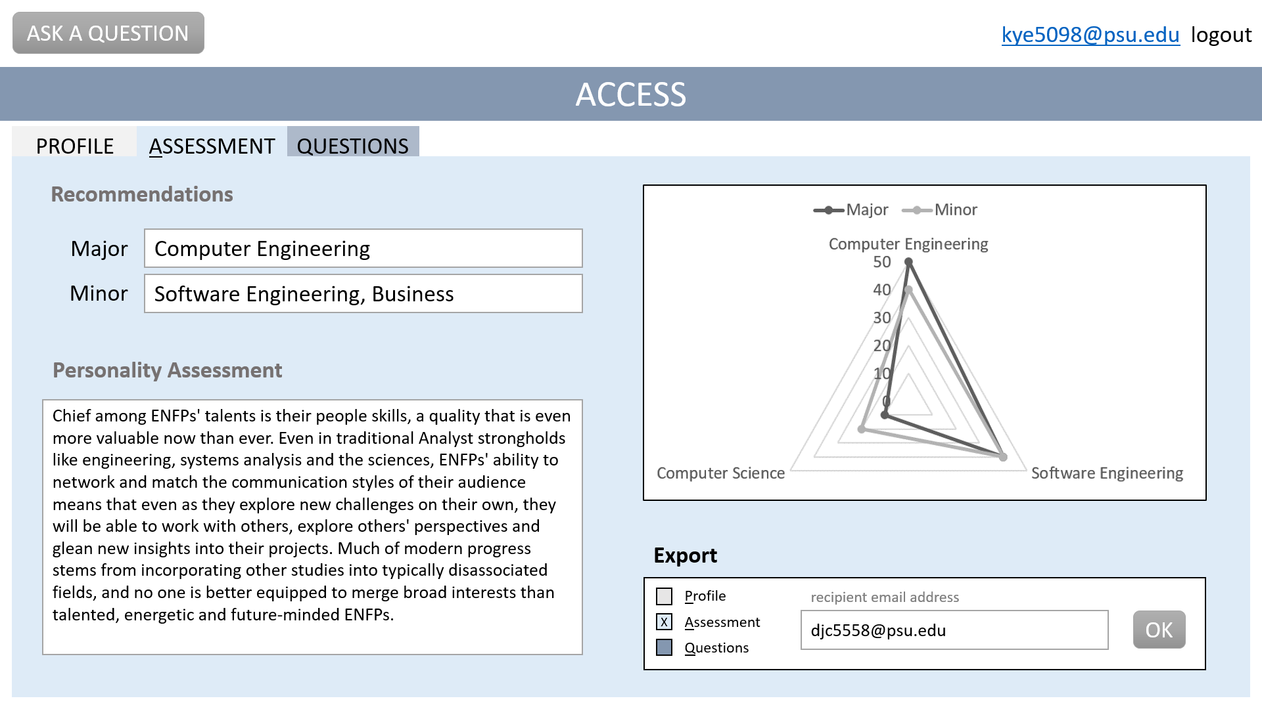

**Assessment:** allows user to view their personalized assessment and to send it, partially or in full, to an email address.

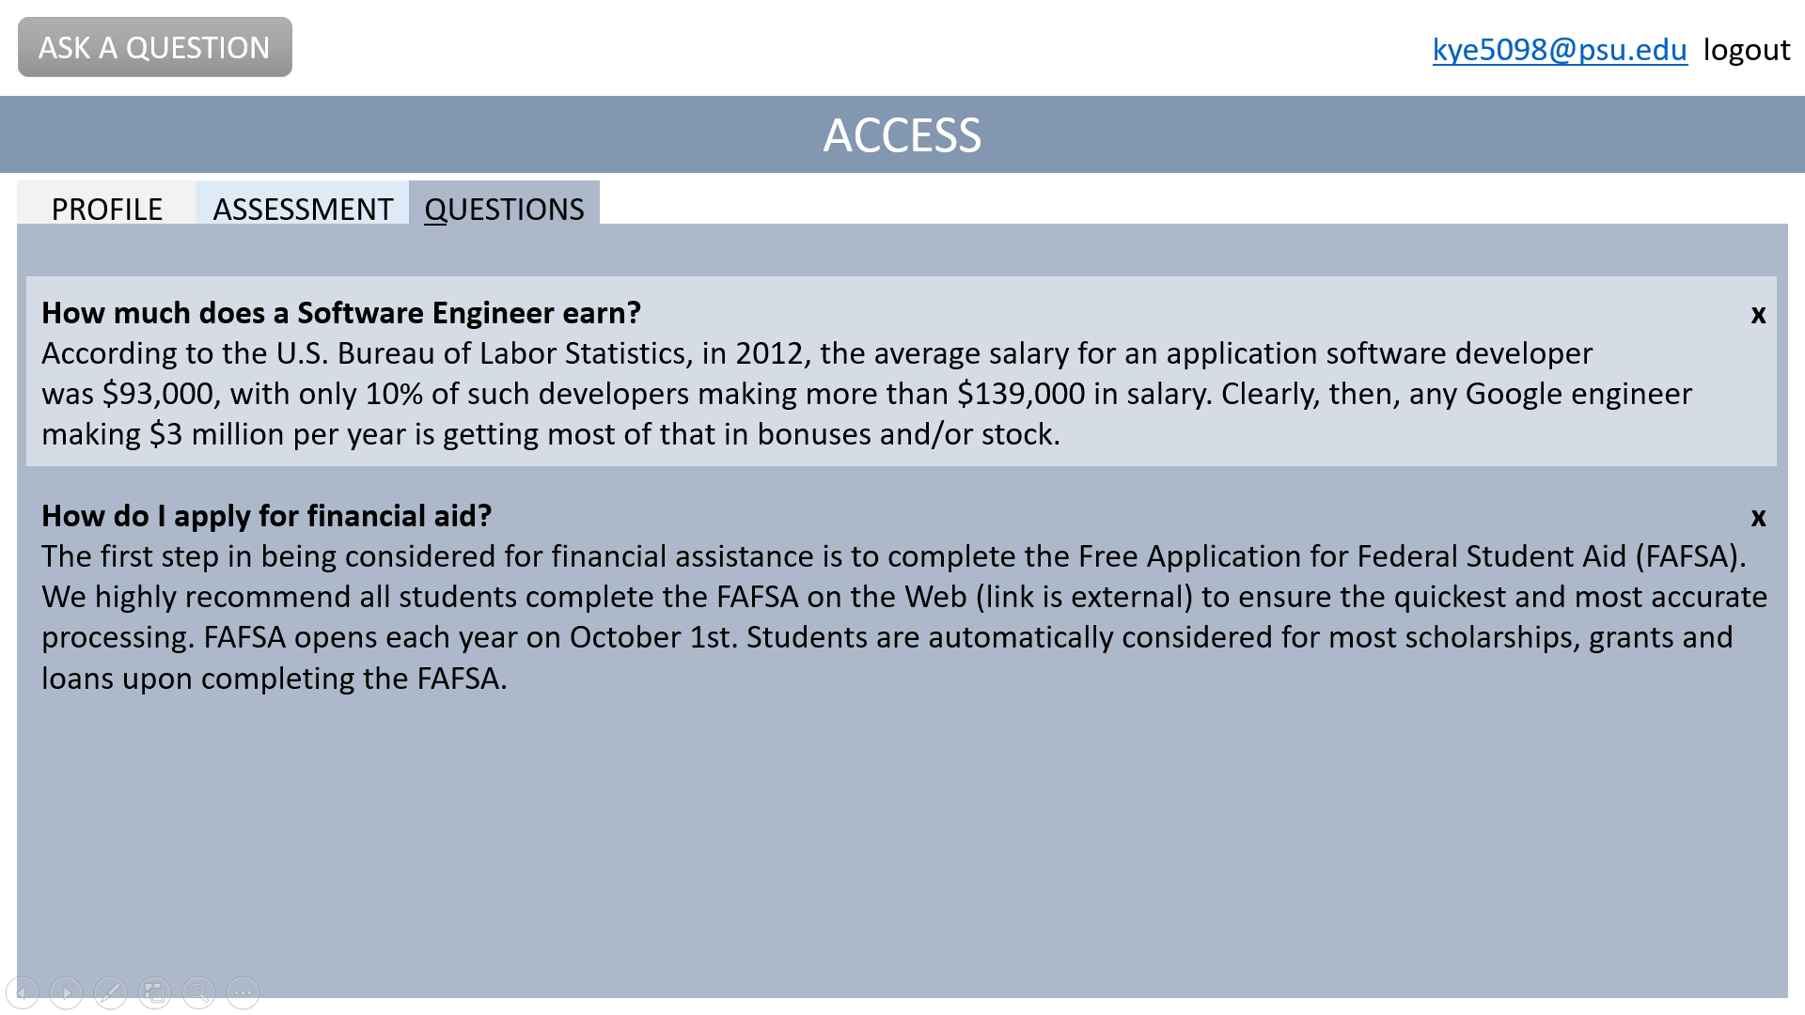***Previous Question Log:*** *displays questions previously asked by users and their preferred answers*

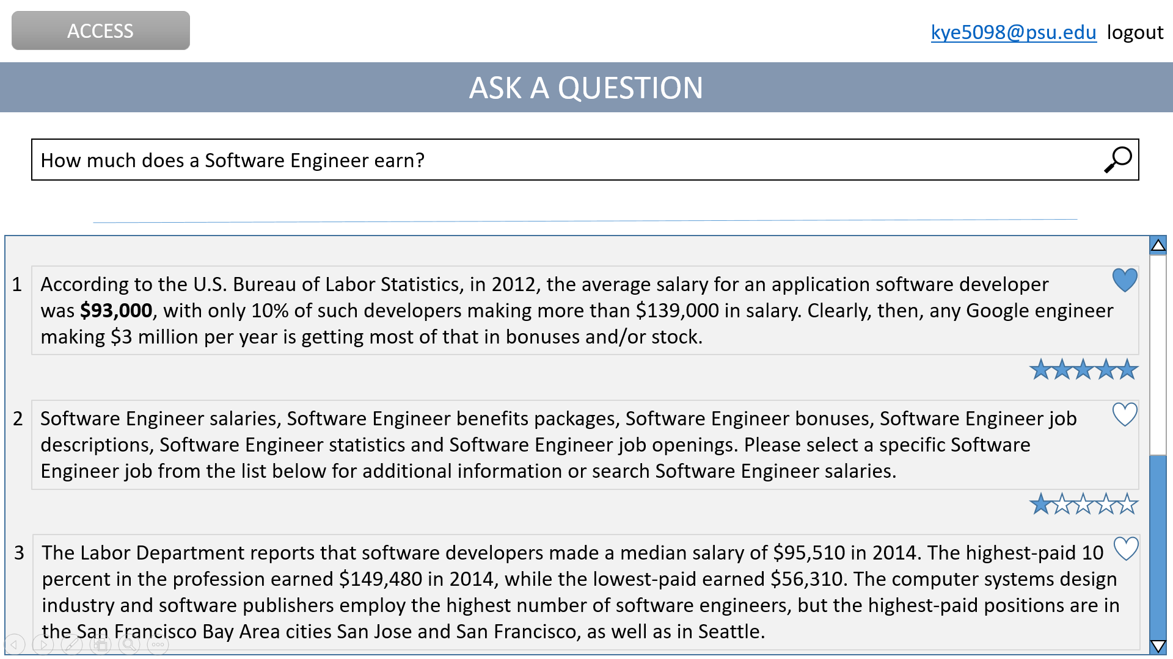***Ask Question Interface:*** *allows user to ask questions, rate the received answers, and select one preferred answer*

### Structural Alternative Designs

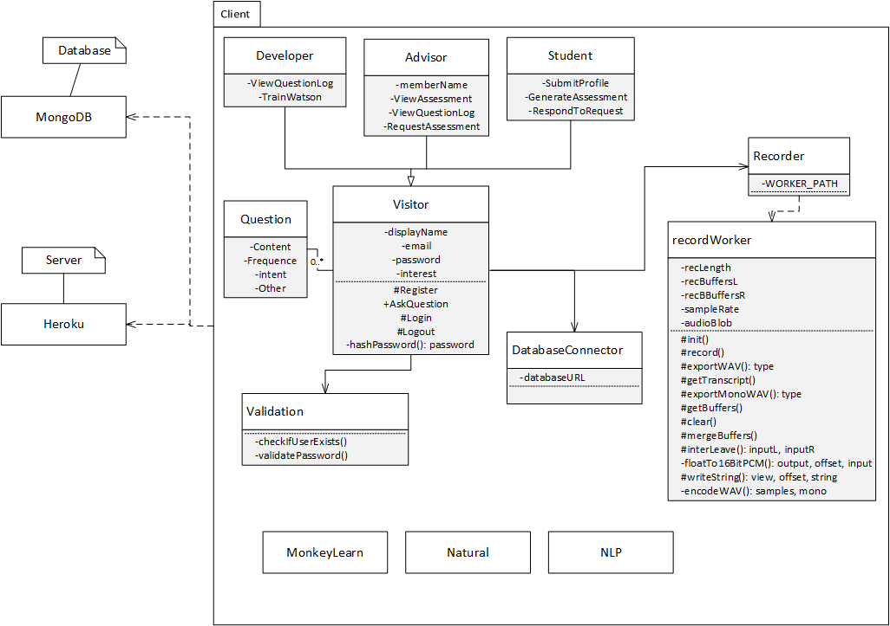

* This design was not chosen because it places a lot of emphasis on the recorder and recordWorker. In addition, they are used for the voice-to-text functionality that we decided to not include.

### Architectural Alternative Designs

* No alternative considered.

### Behavioural Alternative Designs

* No alternative considered.

# System Implementation

## Programming Languages & Tools

* Bluemix (conversation, retrieve and rank, Natural Language Understanding,…)[3][4][5]
  + Input will be parsed by the server, then go into Conversation service to be guided by default classifier, then, if no exception, the question will be answered by retrieve and rank. In parallel, the question and answer will be analyzed by Natural Language Understanding, and placed into the database.
* MongoDB[14]
  + The MongoDB is mainly used to maintain user information, question and answer information, and system analysis.
* Node.js[12]
  + Server application type, programing language in JavaScript style. For production driven development, all libraries will update to the newest version. And programming style will be in industrial standard.

## Coding Conventions

* Use ES6 standard for Javascript

## Code Version Control

* GitHub[13]

## Implementation Alternatives & Decision Rationale

* PHP for Node.Js
  + NodeJS also has the advantage of an easy setup in a local development environment, which is preferred by the development team. Allen has had some experience developing with NodeJS in the past, so he will be able to guide his teammates, should they have questions or need guidance.
* MySQL for MongoDB
  + Although MySQL is more familiar to all of us, traditional databases are not efficient and flexible enough to handle unstructured and big data which in our project we will constantly deal with.
* Project Oxford for Bluemix
  + Since Dr. Su is offering a cognitive system course this semester which Allen is taking, and because Allen already did some projects with BlueMix, it’s better for us to select BlueMix as our main tool.
* Mobile platform for web platform
  + None of the team members have experience in mobile development, so for the sake of quality, we will not attempt to do any mobile native development.

## Analysis of Key Algorithms

* ask_question(input){

humanlizeString(input);

getInterests(input);

formatAIReadable(input);

updateUserInterest(input);

}

* formatAIReadable(input){

Foreach interest in input do:

interestWeight <- getConfidenceOfInterest(input);

input.append(interest * interestWeight)

Return input;

}

# System Testing

## Test Automation Framework

### Steps for Installing Mocha

* Install the new package using the command **npm install --global mocha --save**
* Modify package.json’s scripts to include **“test”: “mocha”**
* Create test file directory with command **mkdir test**
* Edit test script with command **$EDITOR test/test.js**

### Steps for Running Test Cases

* Type command **npm test**

## Test Case Design

For a detailed description of each test case, see Appendix T Tables 8.2.1 - 8.2.25

### Test Suites

**Table 8.2.1: Test Suite TS-001: Unit Tests**: Summary of all Unit Tests. Unit tests check for functionality of specific parts of the code. In these tests, we make sure that the expected result occurs under the specified conditions. For instance, if an invalid password were to be entered, we expect that a person would not log in. This would pass a test.

**Table 8.2.2: Test Suite TS-002: Acceptance Tests**: Summary of all automated Acceptance Tests. In these tests, we make sure that the requirements we have stated in the documentation are successfully being met.

**Table 8.2.3: Test Suite TS-003: Manual Tests**:Summary of all manual Acceptance Tests. These perform the same duties as the automated ones, but are performed manually by our QA Lead (Daria Cook).

### Unit Test Cases

Please see Appendix T for information about individual test cases.

### Integration Test Cases

Integration tests are being done manually.

### System Test Cases

No test cases have been designed for the system at this time

### Acceptance Test Cases

Please see Appendix T for information about individual test cases.

## Test Execution Report

To see a report of each test case being executed, see Appendix TE Tables 8.3.1 - 8.3.24

### Unit Testing Report

All unit tests are passing or failing as expected, depending if a specific feature has been implemented at this time.

### Integration Testing Report

Integration Tests are being done manually.

### System Testing Report

No test cases have been designed for the system at this time

### Acceptance Testing Report

All acceptance tests are passing or failing as expected, depending if a specific feature has been implemented at this time.

# Challenges & Open Issues

## Challenges Faced in Requirements Engineering

* Initially, we struggled to determine the scope of the project. Watson has many features, so we had to be very specific about which of these features would make the most sense for our project’s initial development.
* Understanding the domain, or what sort of questions we wanted Watson to answer.
* Be able to benchmark the accuracy of answering system.
* Be able to automate the training/learning system.
* Getting enough questions to be able to train Watson properly.
* Utilize Natural Language Understanding to preprocess user input in order to increase system accuracy
* Optimize user feedback/system self learning functionality

## Challenges Faced in System Development

* Build and automate the backend system for training with retrieve and rank
* Build workable model to analyze questions and answer accuracy
* Try to utilize IBM Watson API to maximize the performance
* Security
* Migrate AlchemyAPI to Natural Language Understanding due to the deprecation of AlchemyAPI at March 2017.

## Open Issues & Ideas for Solutions

* How to automate handle incorrect answer for system to learn the correct one?

Use cognitive technology compare big data then use probability analysis

# System Manuals

## Instructions for System Development

### How to setup development environment

The Intelligent Academic Planner project is a web application, that will be accessible publicly on Heroku, a Node.JS environment host platform. The source code will be stored by GitHub, for version control purposes. And the server-implementation branch will always be automatically deployed and run on Heroku in development phase. There is no restriction on what IDE will be used by each group member. The ideal team tasks arrangement is 3 team member each work on frontend, backend, testing with domain expert working on training Watson.

### Notes on system further extension

* Automate question and feedback log DB
* Natural language extension[9]
* Analytical library
* Visual recognition on building[7]
* Attitude analysis on question
* Campus direction utility
* Course info helper (location, material, etc…)
* LionPath
* Schedule
* API
* News/feeds utility[17]

## Instructions for System Deployment

### Platform Requirements

NodeJS: main server platform, version require v6.0 and up

MongoDB: version require 3.0.x and up

Modern Web Browser: Firefox, Chrome, Edge, Safari, Opera, Iceweasel

Bluemix

Heroku-Github

### System Installation

NodeJS: local install by installer or any online NodeJS IDE

MongoDB: no installation required

Bluemix: no installation required

Client: user defined browser installation

## Instructions for System End Users

Navigate to the [intelligent-student-advisor.herokuapp.com.](http://intelligent-student-advisor.herokuapp.com/)

Ask a question on the index page by typing the question on the search bar in the middle.

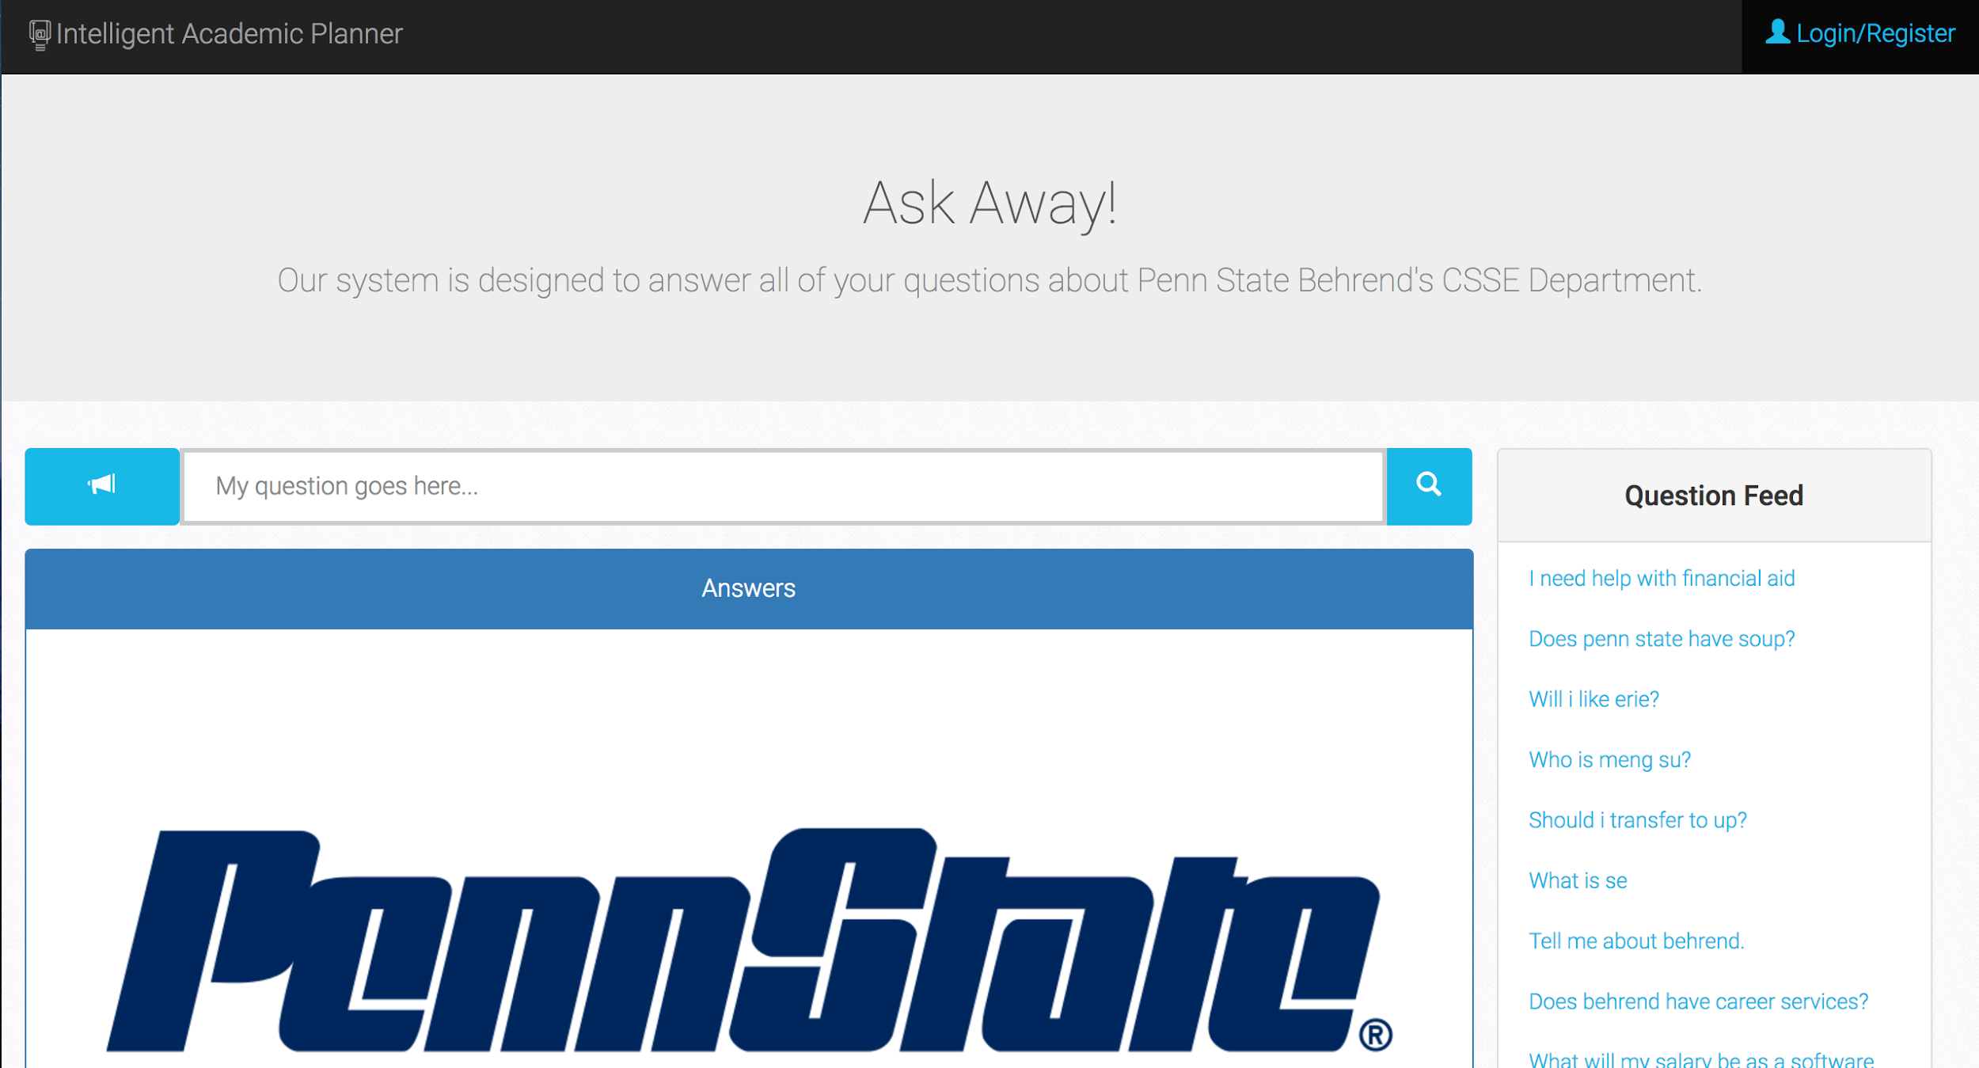

Press the magnifier button or press the [enter] button to ask the question. You should see the answers show up in the answer section as a group of 6. The top answer is on the top with blue background color.

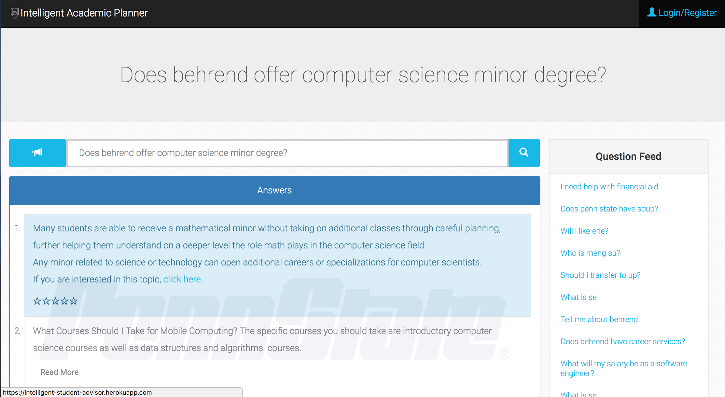

Click on the Login/Register button in the upper right corner to login or register.

Fill email and password to login.

Or, fill first name, last name, email, password and account role to register.

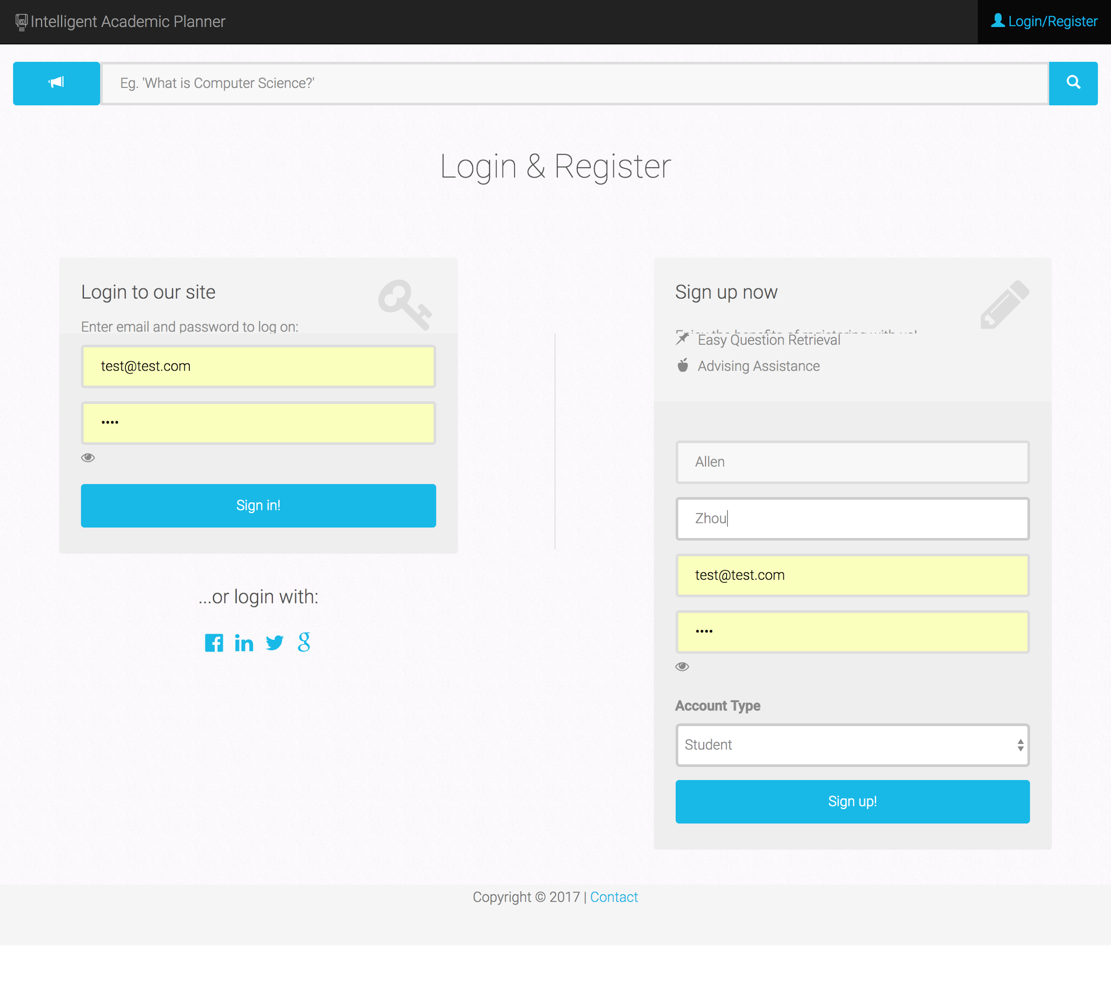

After login, you can favorite and rate answers based on your satisfaction. By favoriting an answer, the system remembers the answer with the question pair for you, you can go to your profile page to view it again in the feature. By rating an answer, the system will learn from your rating and improve itself.

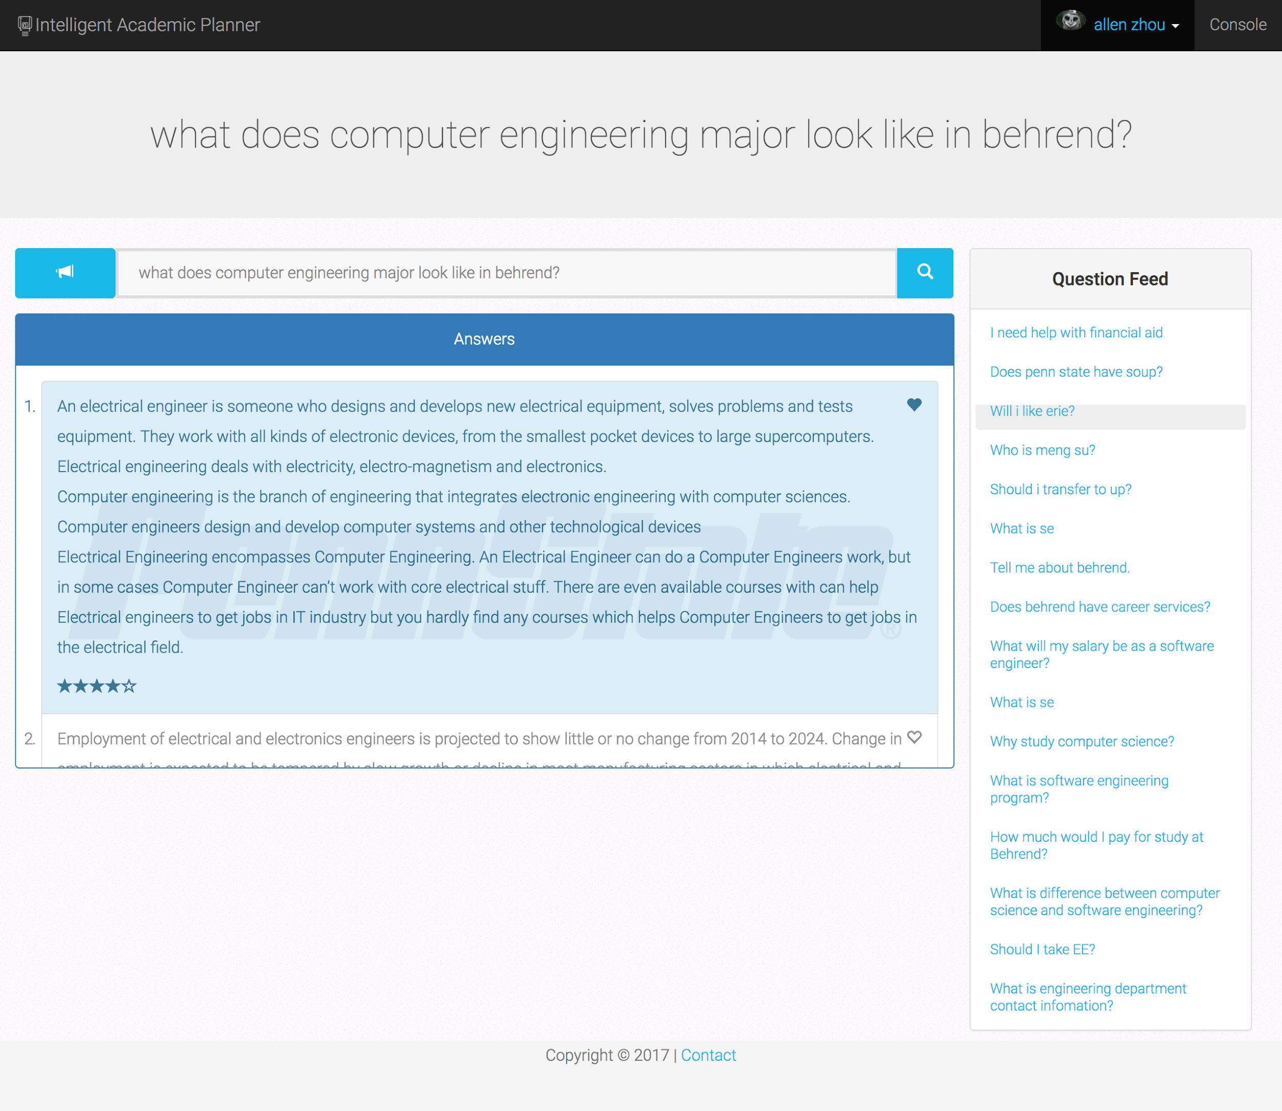

Click your name and avatar on the top right corner, then click the profile button to videw your personal information.

Click the inbox button to view your personal message from advisor(s).

Click the logout button to end the login session and become a visitor again.

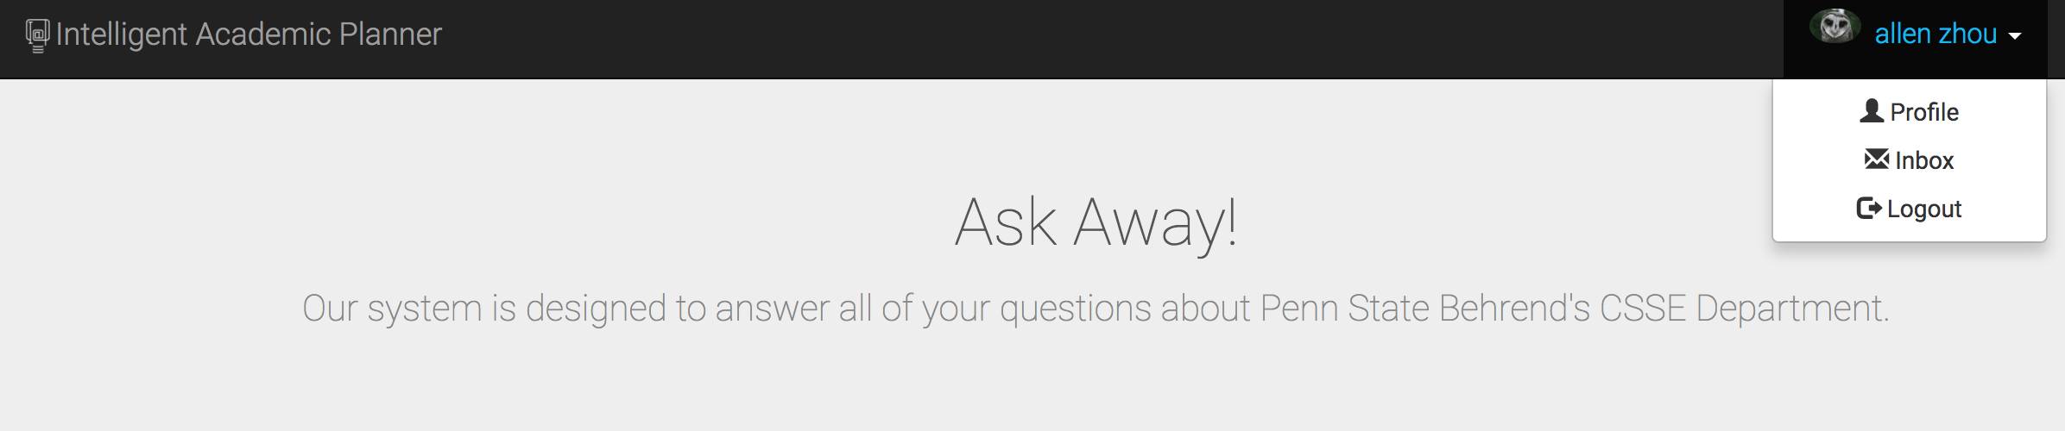

Once you are on the profile page, you can view following section about yourself:

InterestCloud, a key term map indicates your interests from you introduction and questions.

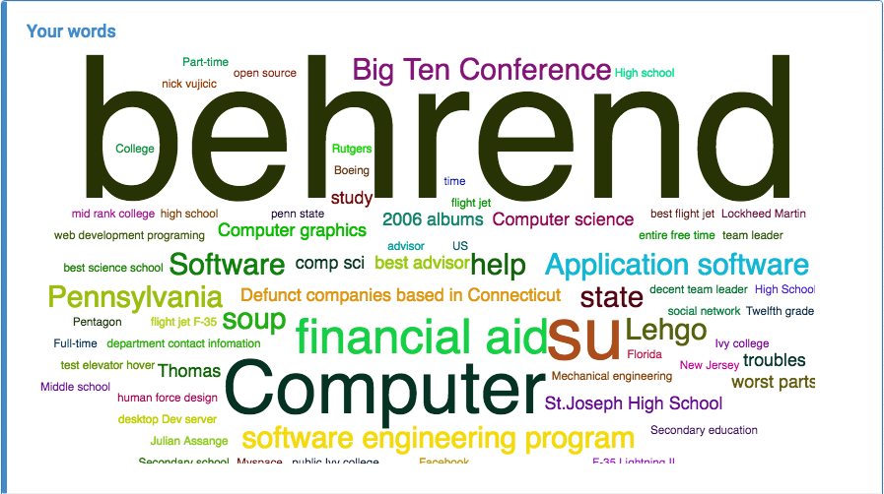

Introduction: where you write a self descriptive paragraph or submit a text/word file about you, if you want to get an analysis about your introduction, you need to input 100 words minimum.

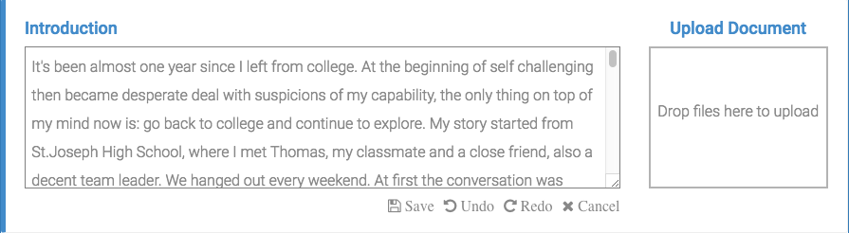

Question history: where shows your favorite question and answer pairs.

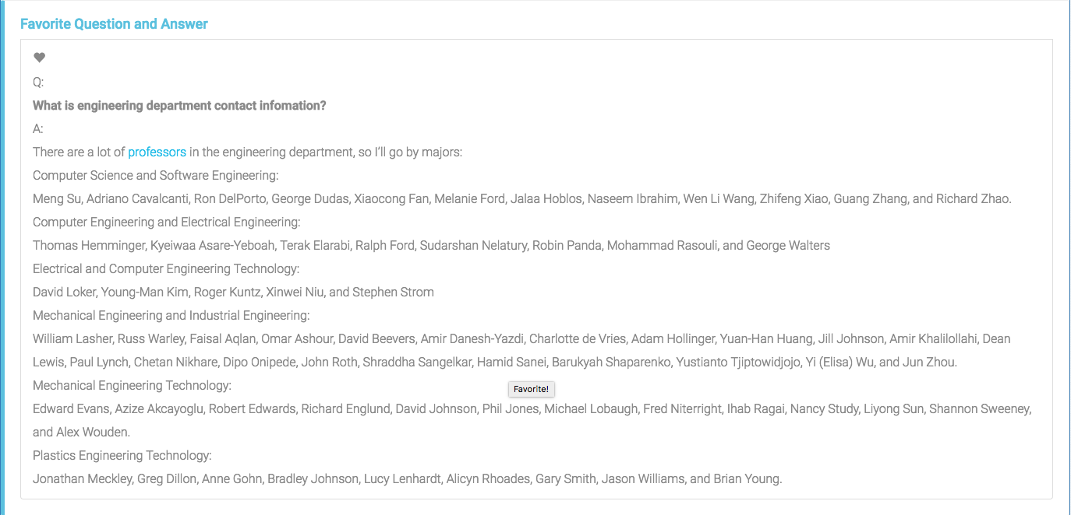

Click any question that someone already asked through the question feeds panel, to know the answer of that specific question.

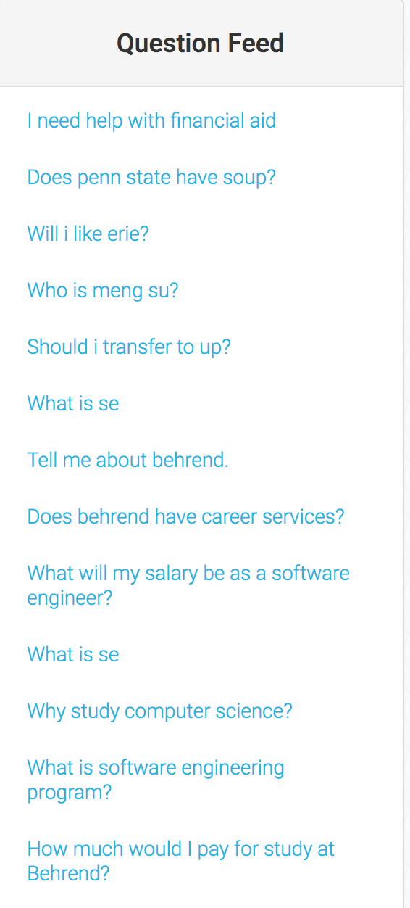

Click the change avatar button to change the avatar on the profile page.

Click the generate assessment to get an assessment of available information from you and send to an advisor.

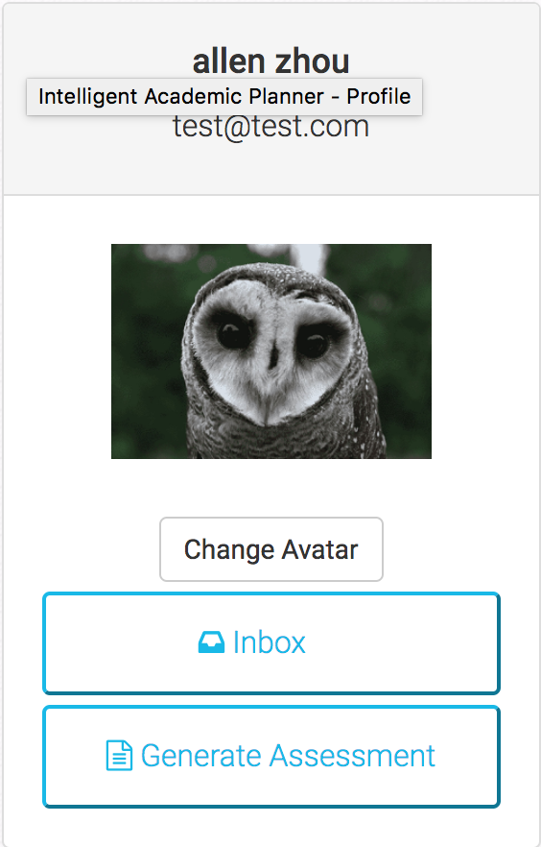

# 

# Conclusion

This section will be gone over in future reports.

# 

# References

1. I. B. M. What is IBM Watson? http://www.ibm.com/watson/what-is-watson.html (accessed Oct 5, 2016).
2. MonkeyLearn http://docs.monkeylearn.com/ (accessed Oct 5, 2016).
3. Natural Language Understanding https://www.ibm.com/watson/developercloud/doc/natural-language-understanding/index.html (accessed Apr 5, 2017).
4. Watson Developer Cloud https://www.ibm.com/watson/developercloud/retrieve-rank.html (accessed Oct 5, 2016).
5. Watson Developer Cloud https://www.ibm.com/watson/developercloud/conversation.html (accessed Oct 5, 2016).
6. Watson Developer Cloud <https://www.ibm.com/watson/developercloud/speech-to-text.html> (accessed Oct 5, 2016).
7. Watson Developer Cloud <https://www.ibm.com/watson/developercloud/visual-recognition.html> (accessed Oct 5, 2016).
8. 3 Types of Survey Research, When to Use Them, and How they Can Benefit Your Organization! https://fluidsurveys.com/university/3-types-survey-research-use-can-benefit-organization/ (accessed Oct 21, 2016).
9. Machine Learning Methods in Natural Language Processing http://www.cs.columbia.edu/~mcollins/papers/tutorial_colt.pdf (accessed Oct 21, 2016).
10. IBM Knowledge Center https://www.ibm.com/support/knowledgecenter/SSSR99/kc/watsoncurator.html (accessed Oct 21, 2016).
11. Essentials of Machine Learning Algorithms (with Python and R Codes) https://www.analyticsvidhya.com/blog/2015/08/common-machine-learning-algorithms/ (accessed Oct 21, 2016).
12. NodeJS <https://nodejs.org/en/> (accessed Oct 21, 2016).
13. Github <https://help.github.com/> (accessed Oct 21, 2016).
14. MongoDB <https://docs.mongodb.com/> (accessed Oct 21, 2016).
15. Language Translator-Translate and publish content in multiple languages. <https://www.ibm.com/watson/developercloud/language-translator.html> (accessed Oct 21, 2016).
16. Personality Insights-Uncover a deeper understanding of people's personality characteristics, needs, and values to drive personalization. <http://www.ibm.com/watson/developercloud/personality-insights.htm>l (accessed Oct 21, 2016).
17. Comparing Closed-Ended and Open-Ended Questions http://fluidsurveys.com/university/comparing-closed-ended-and-open-ended-questions/ (accessed Oct 21, 2016).
18. Pennsylvania State University - Erie <http://www.ratemyprofessors.com/campusRatings.jsp?sid=1291> (accessed November 12, 2016).
19. Pennsylvania State University -- Erie, The Behrend College <http://colleges.usnews.rankingsandreviews.com/best-colleges/penn-state-erie-3333/academics> (accessed November 12, 2016).
20. The Pennsylvania State University <http://engineering-schools.startclass.com/l/223/The-Pennsylvania-State-University> (accessed November 12, 2016).
21. Penn State Erie - The Behrend College <https://colleges.niche.com/penn-state-erie----the-behrend-college/> (accessed November 12, 2016).
22. Frequently Asked Questions - Honors Program <https://psbehrend.psu.edu/Academics/academic-programs/honors/frequently-asked-questions-1> (accessed November 12, 2016).
23. What does a Computer Software Engineer do? Could you give me a description of the field? <http://tryengineering.org/ask-expert/what-does-computer-software-engineer-do-could-you-give-me-description-field> (accessed November 11, 2016).
24. Undergraduate Majors and Minors <https://psbehrend.psu.edu/Academics/academic-programs/majors-minors> (accessed November 11,2016).
25. Computer Engineering, B.S. Curriculum <https://psbehrend.psu.edu/school-of-engineering/academic-programs/computer-engineering/curriculum> (accessed November 11, 2016).
26. Computer Engineering <http://psbehrend.psu.edu/school-of-engineering/academic-programs/computer-engineering> (accessed November 11, 2016).
27. Penn State Erie, The Behrend College <https://en.wikipedia.org/wiki/Penn_State_Erie,_The_Behrend_College> (accessed November 11, 2016).
28. Computer Science & Engineering <http://www.cs.washington.edu/prospective_students/undergrad/faq> (accessed November 10, 2016).
29. Science and Engineering Indicators 2012 <https://www.nsf.gov/statistics/seind12/c2/c2s2.htm> (accessed November 10, 2016).
30. Annual Security Reports <http://police.psu.edu/annual-security-reports> (accessed November 10, 2016).
31. Adult Learner Support Services <https://psbehrend.psu.edu/Academics/academic-services/adult/support-services> (accessed November 10, 2016).
32. Electrical & Computer Engineering <http://www.ee.uh.edu/undergraduate/computer-engineering-faq> (accessed November 10, 2016).
33. Culture and engineering in the USA and Japan <http://link.springer.com/article/10.1007/s00146-003-0280-z> (accessed November 9, 2016).
34. Traveling opportunities as a software engineer? <http://www.flyertalk.com/forum/travelbuzz/920489-traveling-opportunities-software-engineer.html> (accessed November 9, 2016).
35. A job in computers that lets me travel a lot? <http://ask.metafilter.com/88578/A-job-in-computers-that-lets-me-travel-a-lot> (accessed November 9, 2016).
36. Traveling computer jobs <http://www.indeed.com/q-Traveling-Computer-jobs.html> (accessed November 9, 2016).
37. Average weather for Erie, Pennsylvania, USA <https://weatherspark.com/averages/30194/Erie-Pennsylvania-United-States> (accessed November 8, 2016).
38. Campus Dining <http://behrendcampusliving.psu.edu/campus-dining> (accessed November 8, 2016).
39. Tuition Calculator <http://tuition.psu.edu/costestimate.aspx> (accessed November 8, 2016).
40. Find 2016 Engineering Internships <http://www.internships.com/engineering> (accessed November 8, 2016).
41. What is the percentage of junior year computer science students in the top 30 US universities that are likely to be accepted to internships in 2016? <https://www.quora.com/What-is-the-percentage-of-junior-year-computer-science-students-in-the-top-30-US-universities-that-are-likely-to-be-accepted-to-internships-in-2016> (accessed November 8, 2016).
42. Software Engineering / Computer Science difference <https://users.csc.calpoly.edu/~djanzen/secsdiff.html> (accessed November 7, 2016).
43. Pennsylvania State University Erie Behrend College <http://www.studentsreview.com/PA/PSUE_comments.html> (accessed November 10, 2016).
44. Academic Calendars <http://registrar.psu.edu/academic_calendar/calendar_index.cfm> (accessed November 7, 2016).
45. Top 10 Benefits of Becoming an Engineer <http://old.ece.ufl.edu/admission/undergraduate/benefits.htm> (accessed November 10, 2016).
46. How Much Does a Computer Engineer get Paid Per Hour? <http://work.chron.com/much-computer-engineer-paid-per-hour-21954.html> (accessed November 8, 2016).
47. Tau Beta Pi <https://www.tbp.org/home.cfm> (accessed November 8, 2016).
48. Cost of Living in Erie <https://www.numbeo.com/cost-of-living/in/Erie> (accessed November 10, 2016).
49. Computer Hardware Engineer Career <https://www.mymajors.com/career/computer-engineers/education/> (accessed November 12, 2016).
50. What do Engineers have in common? <http://engineeringrevision.com/367/what-do-engineers-have-in-common/> (accessed November 12, 2016).
51. Hobbies that engineers have? <https://www.reddit.com/r/engineering/comments/2ed8sj/hobbies_that_engineers_have/> (accessed November 12, 2016).
52. Computer Engineering, Software Engineering, or Computer Science? <https://engiegirlsatuwaterloo.wordpress.com/2013/08/29/computer-engineering-software-engineering-or-computer-science/> (accessed November 12, 2016).
53. The Big Five Personality Traits https://www.verywell.com/the-big-five-personality-dimensions-2795422 (accessed April 16, 2017).